News letter 2011- 2012

Donal Ryan Chairman
Aileen Byrne Secretary
Emma Jane Nulty Technical Skills Officer
Lua McIlraith PRO
Joanna Troughton Treasurer
John Walsh Property Officer
Sharon Nealon Member
Philip Murphy Member
Geraldine McGrath Member
Alan Nuzum Member
Lorcan McEneaney Chair, Artistic Committee

September 2011
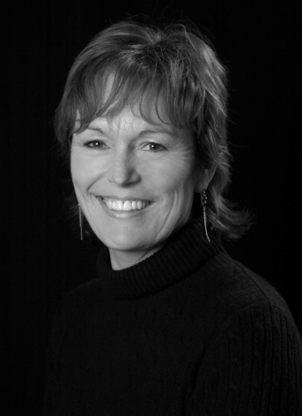
We started off in September with our by now traditional get together in the Vico Room in the Queens in Dalkey . Plans for the year were unveiled and a comedy (at long last )was chosen for our November production in the Town Hall. The female version of “The Odd Couple” by Neil Simon was welcomed by the lady members as a chance to get their teeth into something juicy.

There was added excitement when Geraldine and Roy announced their engagement with the wedding date set for December 16th.

John Walshe got cracking on The Odd Couple and chose the following cast which included three new members.
Olive Geraldine McGrath Florence Sharon Nealon
Sylvie Gillian McElroy Renee Aideen Higgins
Vera Aileen Byrne Mickey Emma Mulligan
Manolo David O Keefe Jesus David Butler
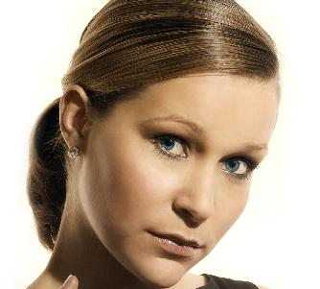 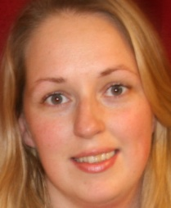 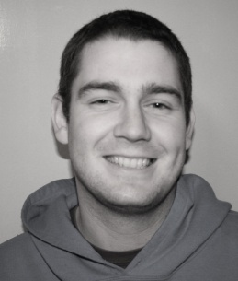 Left to right Gillian Emma and Dave
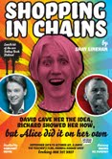
September also saw Dalkey Player members Brenda McSweeney perfom Shay Linehan’s widely acclaimed “Shopping in Chains” in The Teachers Club.
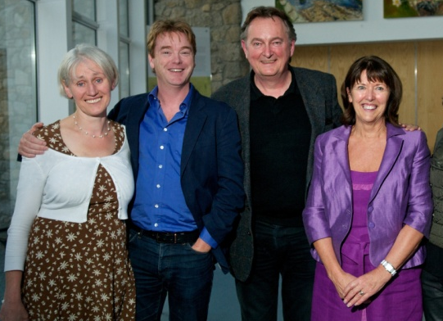
This had been rewritten as a two act play following it’s original outing as a one act in the Dalkey Book Festival. A tour de force from the pair, both in the writing and acting departments. Congratulations to everyone involved.
Brenda McSweeney Shay, Linehan and Margaret Dunne with David McWilliam

October .
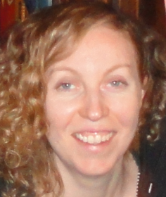
During October Cary Hall rocked with helpless laughter each night during rehearsals as the cast got to grips with Neil Simon’s hysterical script. It really was an immensely enjoyable rehearsal schedule with star Stage Manager Carmel Drumgoole.
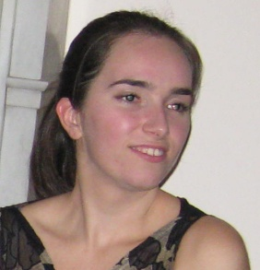
She was ably assisted by another newcomer Maria Bruce playing an absolute blinder. These sorts of sentiments are normally attributed to actors, but this pair had backstage activities running like clockwork.

While rehearsals were in progress we heard that Dalkey Players had been chosen from a number of south County Dublin Drama Groups, to work with Conall Morrison the Director in Residence with the Pavilion Theatre in Dun Laoghaire. This would consist of four workshops two for aspiring and current directors to be held in December and two with actor’s participation in January 2012...... More about this later.
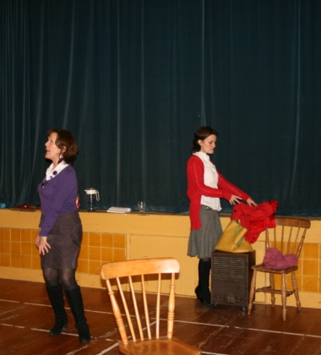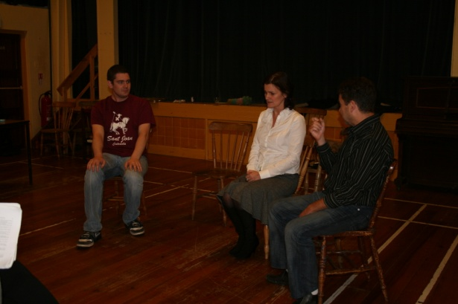
The Odd Couple in Rehearsal

Late October saw Lua McIlraith chosen to direct the One Act Festival for Bray next January . The play of choice is a two hander “The Colour of Grass” translated by Canadian David Nicholson from a nineteenth century French play.

Former member and award winning actress Aine Magennis who has returned to Canada, was instrumental in bringing this play to our attention. She also dropped in to see us on a brief visit back to Dublin in April 2012

November
was a frenzy of activity as we counted down to the start of” The Odd Couple” run. Even though those involved had been to most rehearsals we were still laughing at the antics of Olive and Florence. The audience were thrilled with the performances and we even got this lovely email from an audience member the following week
Date: Thu, 24 Nov 2011 16:45:03 +0000 Subject: The Odd Couple
From: lo.mcgilligan@gmail.com To: dalkeyplayers@hotmail.com
Hi there - this email is for everyone of course but especially for you, Geraldine McGrath - was at the Odd Couple last night and absolutely rocked out of the seat - it was a fantastic show, - I brought two friends with me and they really enjoyed it - many, many congratulations to all - hope you have a great night next Saturday - You know Geraldine I haven't got your phone number so wasn't able to text you - Also congrats to Lua ( I think I know you from Reflexology) Anyway I will spread the word - Very best wishes - Dolores (McGilligan),
Well we took Dolores at her word and had a “rocking party” chez John and Geraldine on the last night. John produced his incomparable curry with all the trimmings served on beautiful china, in elegant surroundings. He could have given Olive and Florence a few lessons........The two Daves with guitar got the singing going and a lively night was had by all.

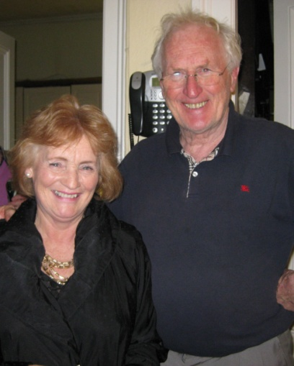
Angela Lambert and John Walsh
The two Daves
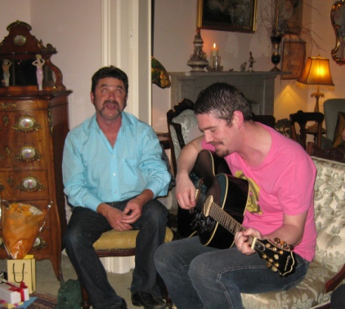 Gillian McElroy 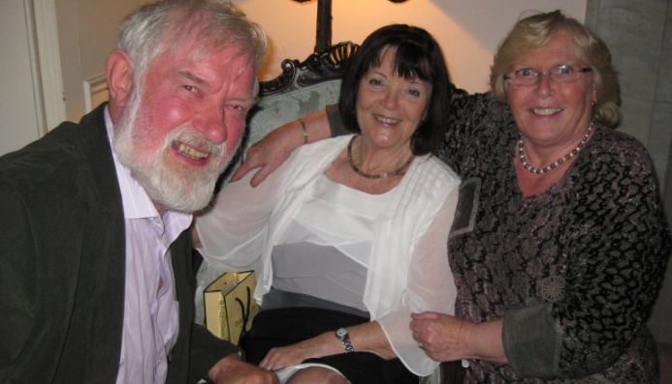
Paddy and Mary Rigney and Lua McIlraith Aideen Higgins Geraldine McGrath and Margaret Dunne

December arrived in very wet fashion but fortunately no snow.
“The Odd Couple” put to bed, there was no letup. Lua held auditions for “The Colour of Grass” as we waited to hear if we would be accepted for the Bray One Act Festival. Emma Jane Nulty and Dave Butler were cast as Marthe and Pierre and rehearsals began straight away. But first there were the Workshops to attend.

Conall Morrison is an Antrim born, Dublin-based writer and director. In brief he has worked for the Abbey Theatre, the Lyric and other companies in Ireland; he has directed work for the Royal Shakepeare Company, English National Opera and the Royal National Theatre London as well as working in many other countries
There was great interest shown in the Conall Morrison Workshops and 20 of our paid up members arrived to the Green Room in the Pavilion theatre for the first of the” directors at large” event. Conall was a warm, friendly, no nonsense, brilliant story teller and encouraging mentor for the group. His tips for getting to grips with a script, casting ,the need for passion and commitment struck the right note with us all and we continued the valuable instruction in Cary hall two weeks later. Each of us got something relevant to our own experiences from his many stories ,a lot of them about his own mistakes over the years of directing...... salutary tales from which to learn. Roll on the January acting workshops.
We learnt that we had been accepted for Bray and were allocated the last slot on the Friday night which suits us beautifully. Then to add an extra spice to proceedings David Nicholson who translated the original play announced that he would travel from Canada for the occasion.
David Nicholson “ so no pressure then ” What pressure!!!

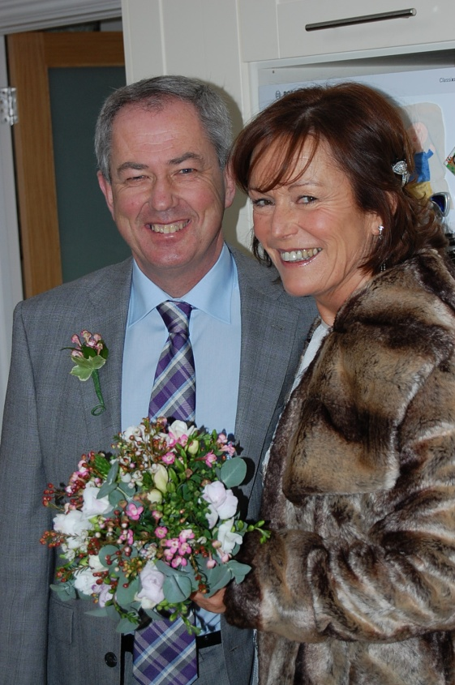
We finished 2011 with the best production of all.
The Big Wedding
Geraldine and Roy at their happiest best. The Dalkey Players contingent made this fabulous night part of their Christmas festivities and a right royal time was had by all. We wished them all the happiness in the world as they set off for their South African honeymoon.

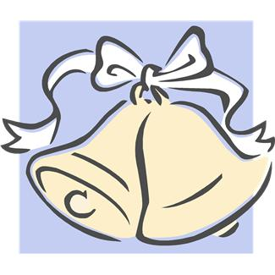

January 2012
January started with our postponed Christmas dinner in The Queen’s Steak House. Twenty or so of us had a great night and we even did the New Year Kris Kindle bit
Les grandes dames de Dalkey Players.......don’t cross them !!!
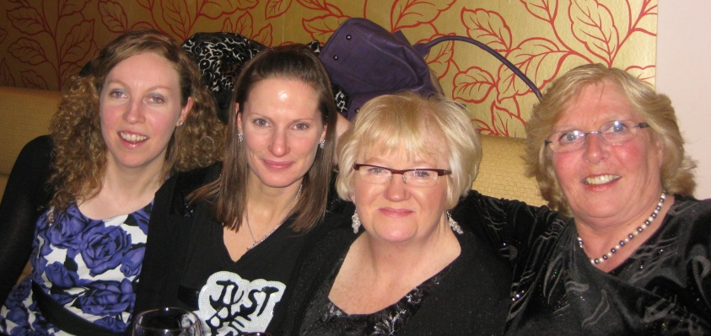 The Wans
Bottoms up
What play are we doing Donal????

twisted....... really early in the night
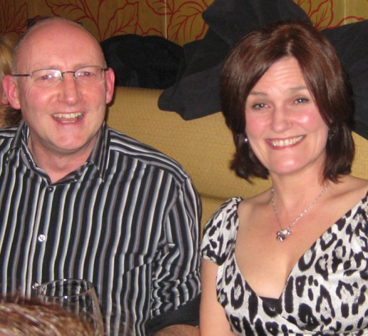 Happy or wha!!!!!!! Philip admires the gals
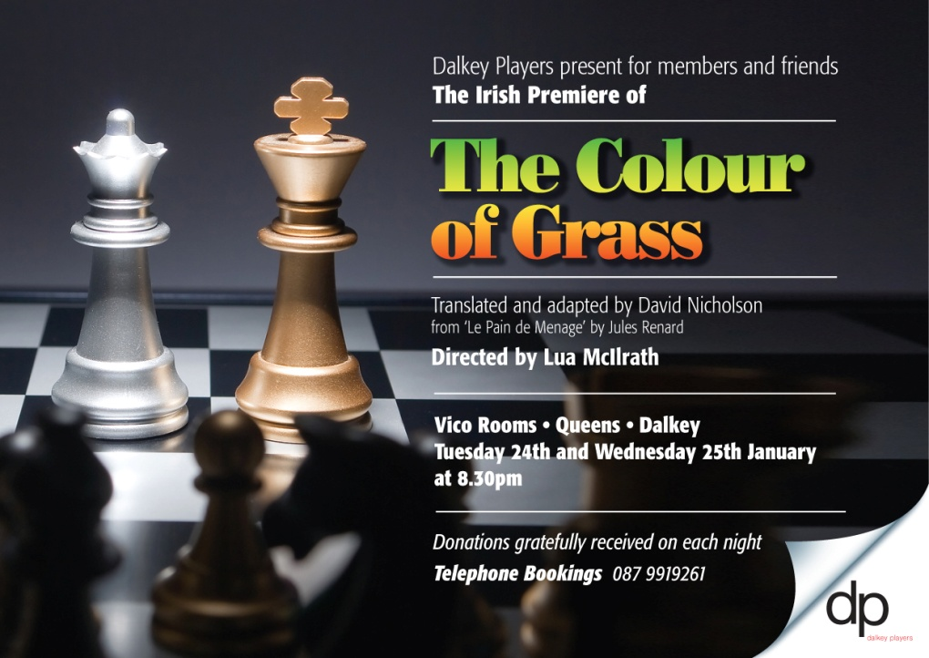
Bray One Act Festival
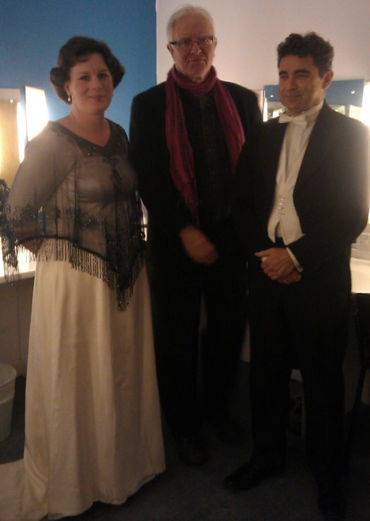
As D-Day for Bray approached Emma Jane and Dave were being whipped into shape twice weekly by Lua, culminating with two performances in the Vico. We had a rent- a -crowd audience on the Tuesday night with people who failed to get into the meeting in the Town Hall happily joining us instead. Everyone remarked on how well our garden setting looked and it set the tone for polishing performances before the arrival of the Author. We learned that this was now an Irish and World Premiere.
On to Bray and Emma Jane and Dave excelled themselves and the Play, director, and author got bountiful praise from Anna Walker the Adjudicator. You all got the email with the results but just for the record this is how we fared.
Nominations
Best Director Lua McIlraith
Best Lighting Kevin Murphy operated by Lorcan McEneaney
Certificate of Merit (For adaptation of Play) David Nicholson.
Best Actress Emma Jane Nulty who won the award.
Rave reviews from adjudicator for Emma Jane and she gave great praise for David’s character portrayal and Lua’s direction.
The icing on the cake was the award for David Nicholson who had come from Canada especially for the occasion so we had a ball.
So congratulations all round on a job well done.

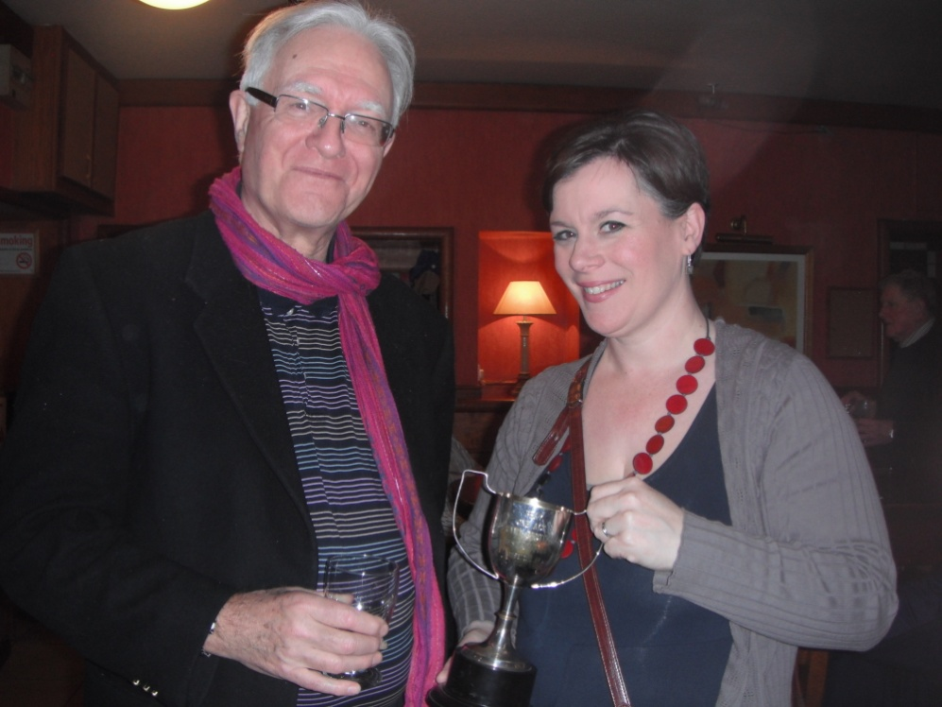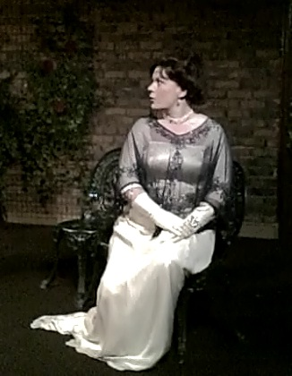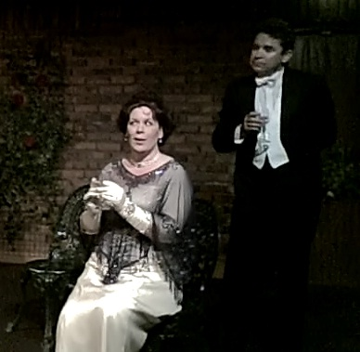
Best Actress Emma Jane Marthe with Pierre
With David Nicholson
Our Spring Production
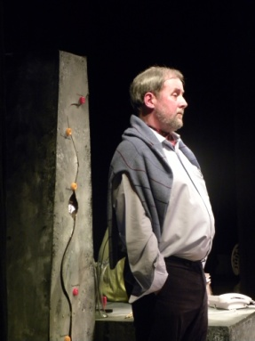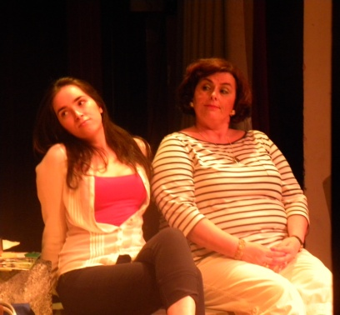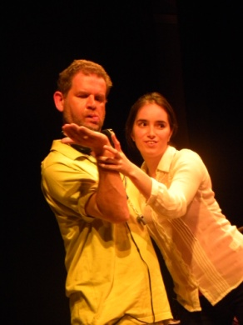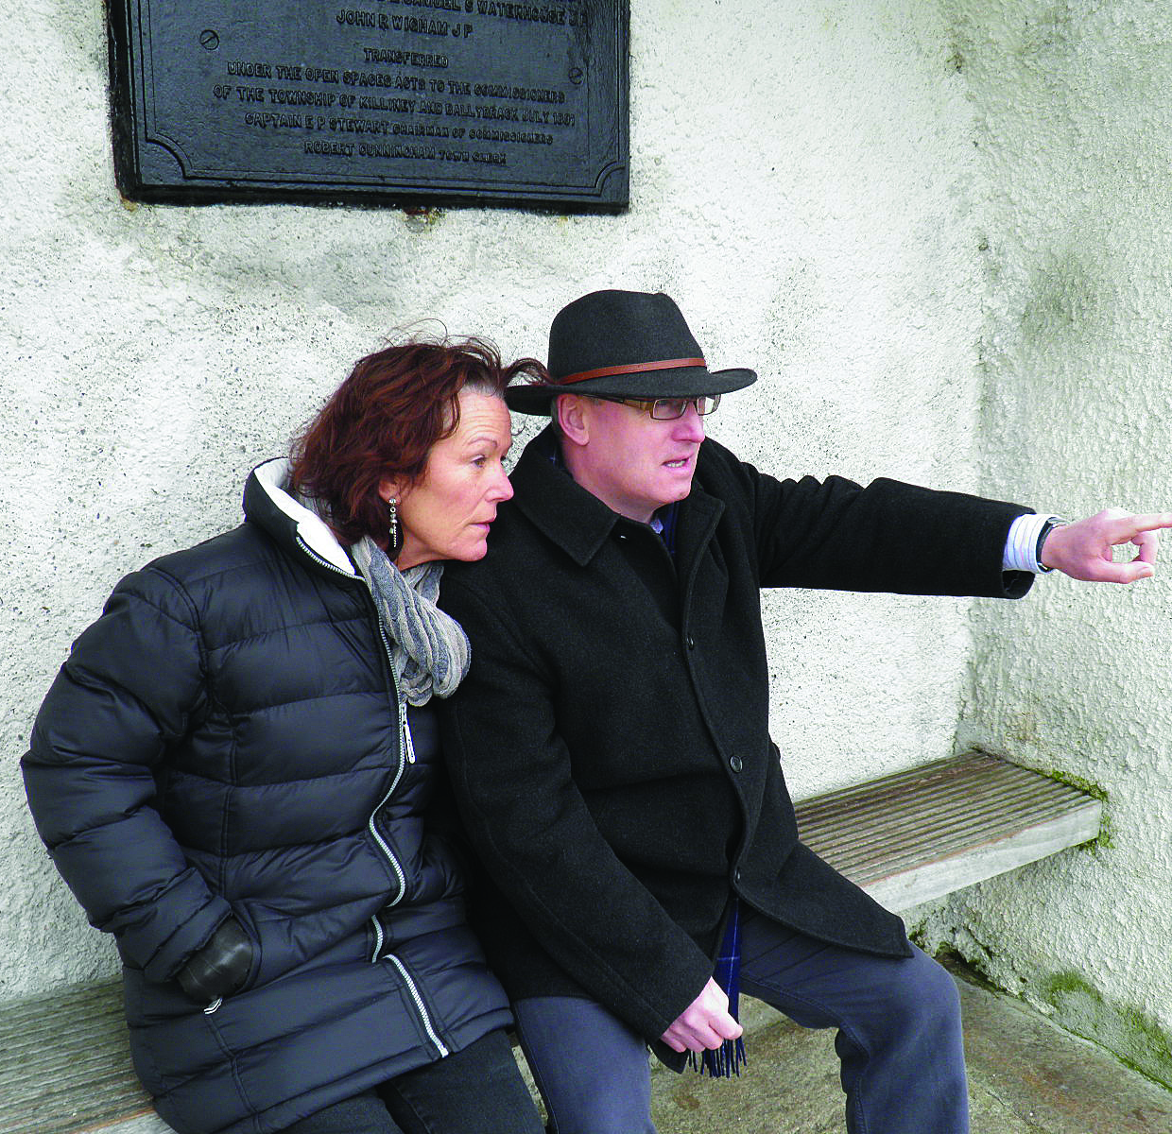
Hugh Leonard's Pizzazz (Three One Acts) in the Dalkey Town Hall from 7th - 10th March 2012.
The three plays .
Roman Fever - Director - Dave Butler- Cast - Sharon Nealon- Anna Fitzgerald
View from the Obelisk- Director - Aileen Byrne Cast Geraldine McGrath Paul Dignam Mathew Kelly
Pizzazz Director - Gerard Bourke Cast Emer Casey Maria Bruce Alan Nuzum Philip Murphy Geraldine McGrath
Link Piece Director - Norman McCausland Author/player - Dave Butler
Production Manager and adviser Emma Jane Nulty

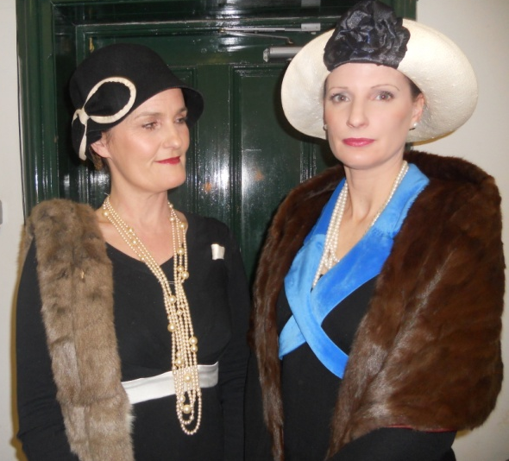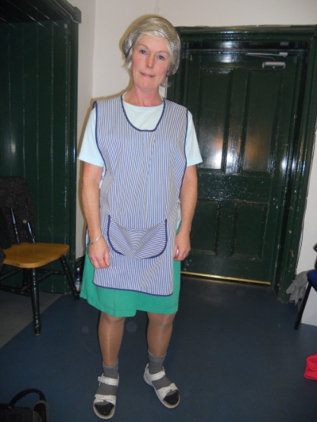
Roman Fever The Obelisk Trio Glamorous Geraldine

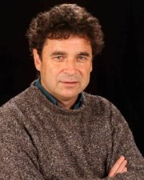
Just as the plaudits for his Bray performance as Pierre are still ringing in his memory, further congratulations are in order for David Butler who has had a book of short stories accepted for publishing in London early next year. He has also won first prize for a short story in a competition run by the Writers Centre and is hoping that his current novel-in -progress will also be making it to the printing presses.
Founder member Josie Dixon’s 80th birthday. We had Flowers, Cake and Candles in Carry Hall to honour her. She had a wonderful surprise when her family gathered from far and wide for the occasion. We wished her many more marvellous birthdays to come.
What would we do without them ????? The unsung heroes, otherwise known as the backstage boys and girls.
Lighting up Sounding off Dresser Supreme Make up Madame
Lorcan McEneaney Tom McMahon Mary Rigney Angela Lambert
Congratulations to the Dalkey Player member worth his weight in gold for his 24 carat contribution to the workings of Dalkey Players. Who are we talking about...none other than John Walsh who had a precious metal celebration of his own recently namely his and Geraldine’s Golden Wedding Anniversary. Continued long life and happiness to the long lasting couple.

The Dalkey Players Baby Boom

Maura Lavelle’s January production ”Milo” with big brother Fionn.
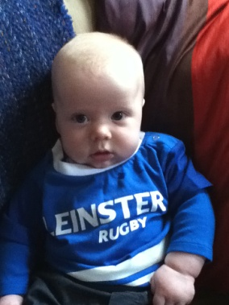
Phillip Murphy’s gorgeous grandson Conor

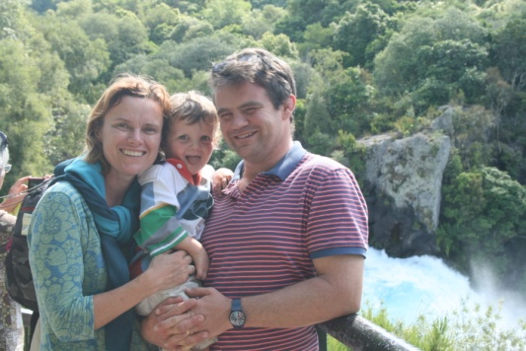

We welcomed Mary Carroll hubby Will and son Hugo back from her family trip around the world. Here they are at Huka Falls New Zealand. Life must be very boring in Shankill after that that amount of travelling or is Ireland still the best place to be.........

Norman McCausland and Tara’s Blair’s Wedding took place on Friday 13th April and many Dalkey Player members were on hand to wish the happy couple a wonderful life together.

B2B is underway as I write with directors and actors going into action. The date is 17th May in Carry Hall.

Programme
Onions by Shay Linehan Forwards by David Butler
Plaster by Richard Harris All My Sons by Arthur Miller Excerpt
Hysteria by Excerpt
Those involved
Directors: Joanna Troughton Aileen Byrne John Walsh Mo Hudson Lorcan McEneaney
Actors Donal Ryan Lua McIlraith Geraldine McGrath Emma Mulligan Phillip Murphy
Alan Nuzum David O’ Keefe Naomi Linehan Cian O ‘Sullivan

And finally to round up the year to night is AGM night.

Looking forward to another great Season

Lua McIlraith PRO/Editor

.

Previous Productions Name these shows 