News letter 2012- 2013

Donal Ryan Chairman
Aileen Byrne Secretary
Emma Jane Nulty Technical Skills Officer
Lua McIlraith PRO & Chair, Artistic Committee
Joanna Troughton Treasurer
John Walsh Property Officer
Emma Mulligan Facebook updates
Sharon Nealon Member
Philip Murphy Member
Geraldine McGrath Member
Alan Nuzum Member

September 2012
Our opening night this year was held in Carry Hall Killiney as this is going to be our rehearsal home for the coming season. Plans to relocate to Dalkey were not feasible unfortunately, but c’est la vie. Plans for the year were unveiled and a classic American Drama” All My Sons” by Arthur Miller was announced as our November production to be directed by Aileen Byrne. This will be performed in Shankill Parish Hall as the Town Hall Dalkey is out of commission until the end of January. Auditions had already started and were continued on opening night. The Bray One Act play had yet to be chosen and readings of possible plays will continue in tandem with the main production. “Love Loss and What I Wore” by Norah Ephron with an all female cast was the front runner for the Spring Production.
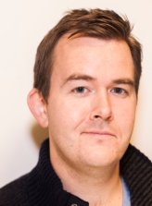 New members Emma Grealy Colm Kearns and Eugene Hill.
Cast of All My Sons
Joe Keller Phillip Murphy Kate Keller Geraldine McGrath Chris Keller Eugene Hill
Ann Deever Allison Davis George Deever David Butler Jim Bayliss Alan Nuzum
Sue Bayliss Joanna Troughton Frank Lubey Colm Kearns Lydia Lubey Emma Mulligan
We welcomed newcomers Eugene Hill and Colm Kearns to Dalkey Players as well as Sarah Louise Flannery and Emma Grealy.
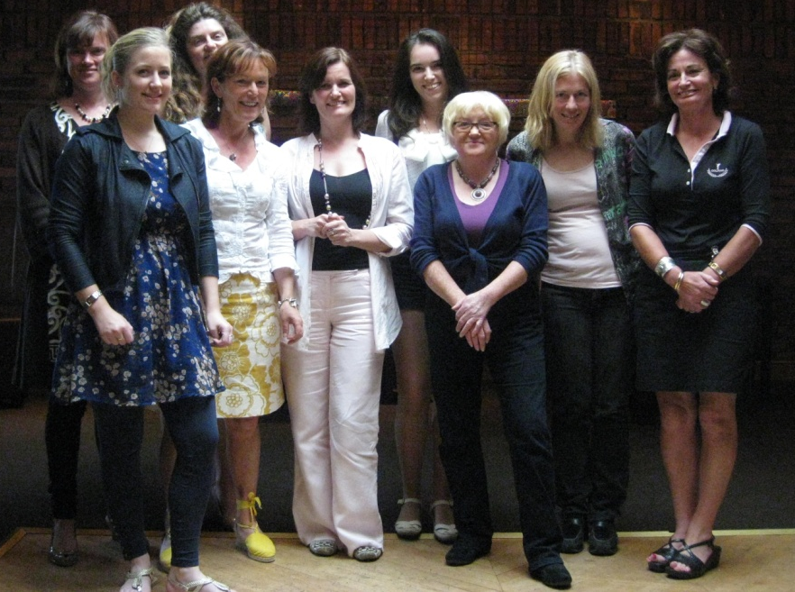
Auditions in the Vico Ladies to the fore as usual
Back row from left
Mary Carroll, Joanna Troughton, Maria Bruce
Front Row from left
Alison Davis, Geraldine McGrath, Sharon Nealon, Aileen Byrne (director)
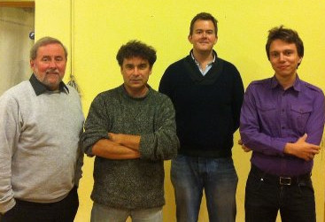
Sarah Louise Flannery, and Carol Dillon

Some of the Gents in Carry Hall
Left to right: Phillip Murphy, David Butler and our newcomers Eugene Hill and Colm Kearns .
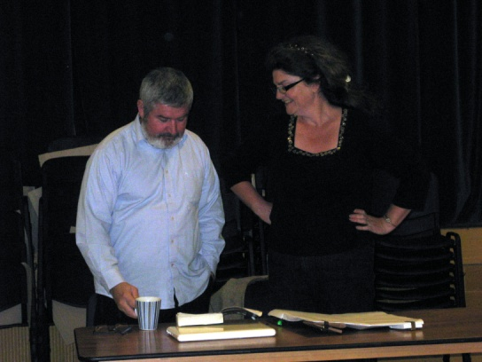
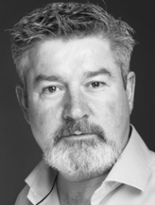
Denis Taylor with friend and member Joanna Troughton, who organised the Accents workshop.

Our first Mini Workshop was given by actor Denis Taylor on how to achieve an authentic American accent. This was particularly relevant for our current cast and was a most enlightening hour with tons of food for thought and a healthy respect for our hardworking tongues. Denis will be back with us later in the year for more tips on how to do accents.
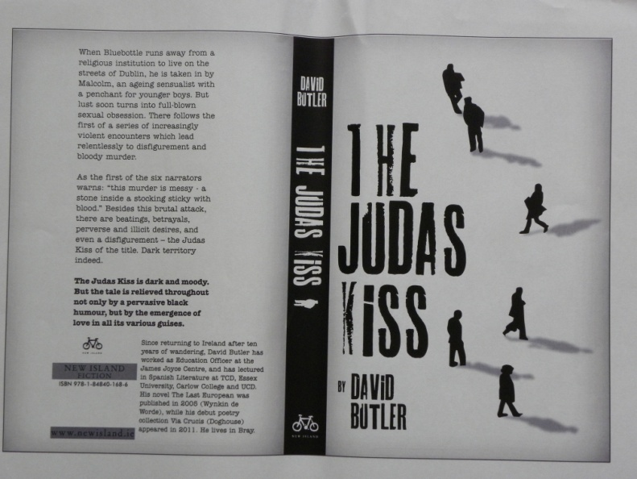
Congratulations to David Butler on the publishing of his second novel due out on October 2nd. Guess he’ll be too busy with the launch to be at rehearsals that night…………we’ll forgive him.
Photo shoot for All My Sons
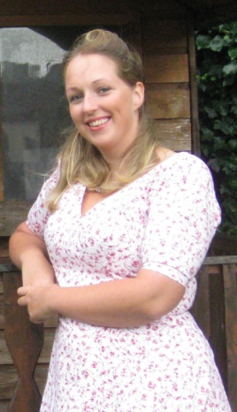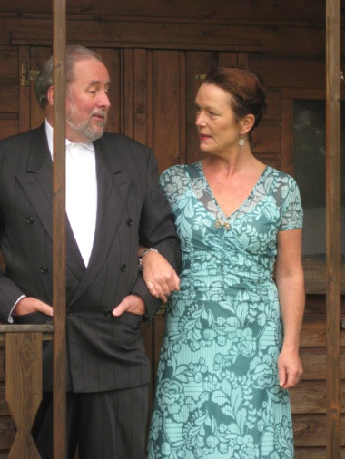
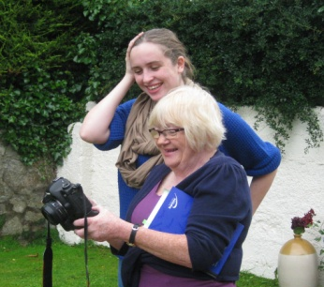
Aileen’s garden was the substitute for the Keller abode . Shot by Lucy Nuzum using Phillip, Geraldine, and Emma. Costumes by Mary Rigney , Hair by Lua.
Lua poses with Joe Keller and Aileen and Lucy check the photos. **********************

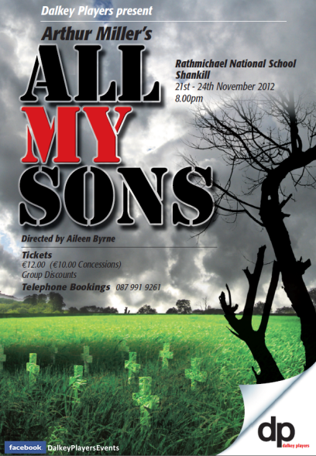
October .

Rehearsals are powering ahead and the tension is building. Aileen is finding out the hard way just how time consuming directing a full play can be. Poster for the play is very eye catching courtesy of our graphic genius Philip Murphy. Production Manager Lua McIlraith is panicking over the Budget as Gerard’s Set Design takes shape. Emer Casey is recovering from a broken ankle and hobbles around with her large supportive boot.

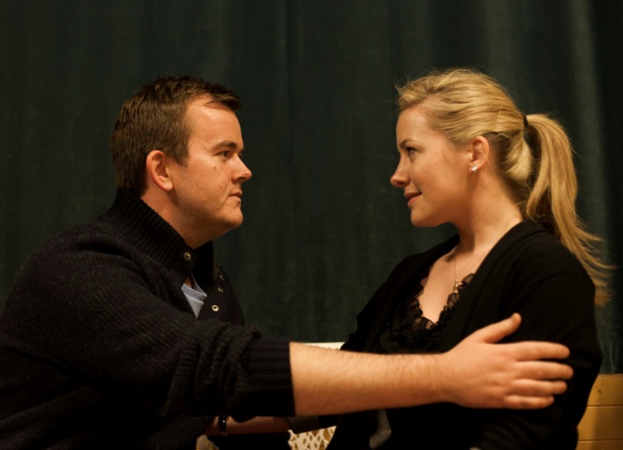
We continued to read One Act plays for the Bray Festival while searching for a prospective director. Happily Emer put her name in the ring and while convalescing with foot up, came up with a selection she was interested in doing. Bearing in mind that the Spring production has an all female cast there was an element of “ keep the lads happy” lurking, so “Fool for Love” ( with judicious cuts ) by Sam Shepherd was chosen. It has a cast of three males and one female. We will wait with baited breath to see if the Bray committee will accept it. Rehearsals are progressing for “All My Sons” with the usual ups and downs of AM Dram.
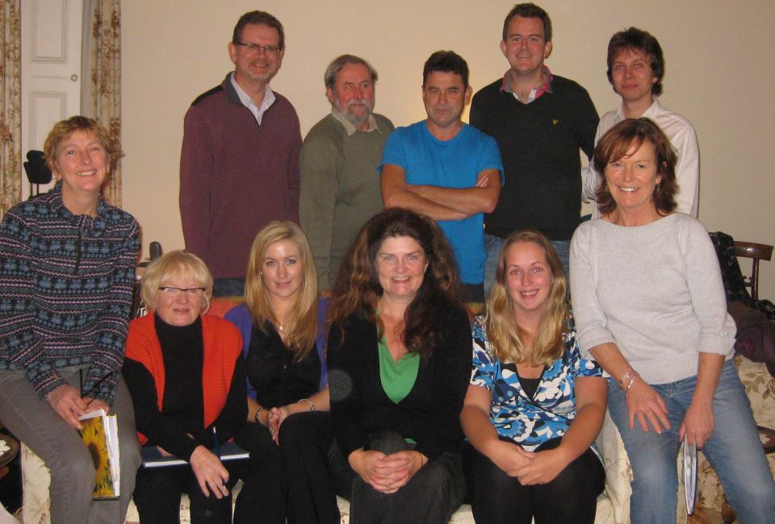
November Allison and Eugene as Chris and Ann
Carry Hall was unavailable for a week so rehearsals continued in the warmth and elegance of Phillip’s lovely home in Monkstown. Tea coffee and “bickies “on tap not to mention the warmth of the open fire. Not that we don’t love Carry Hall but this was com…………..fort personified. Many thanks Phillip for hosting us.
The cast with Director Aileen and Stage Manager Aideen relaxing in Phillip’s sitting room during a break from the emotional content of the show.
The usual crew descended on Rathmichael Parish Hall to create the set on the weekend before we opened and this was the result……one of the nicest sets for some time was the general consensus. 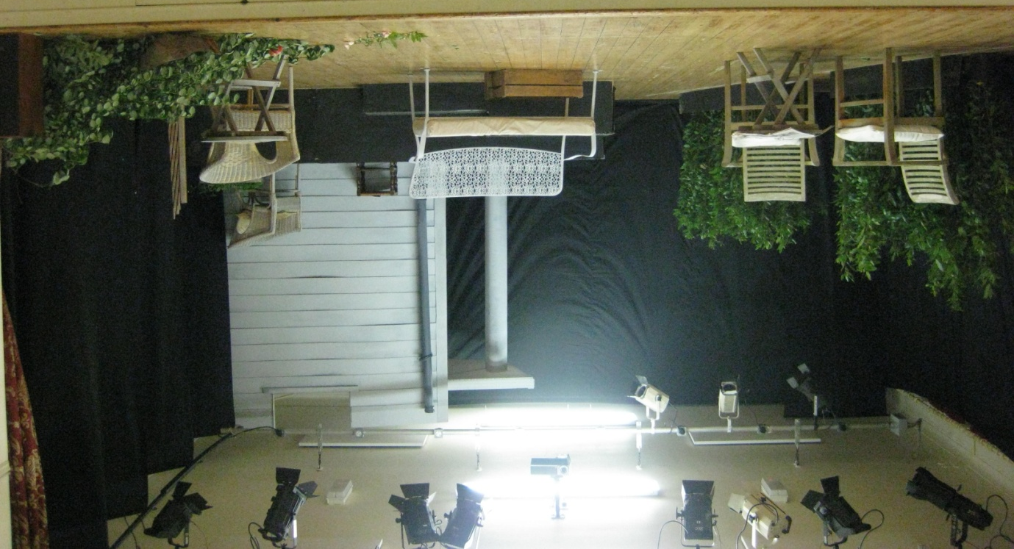
All My Sons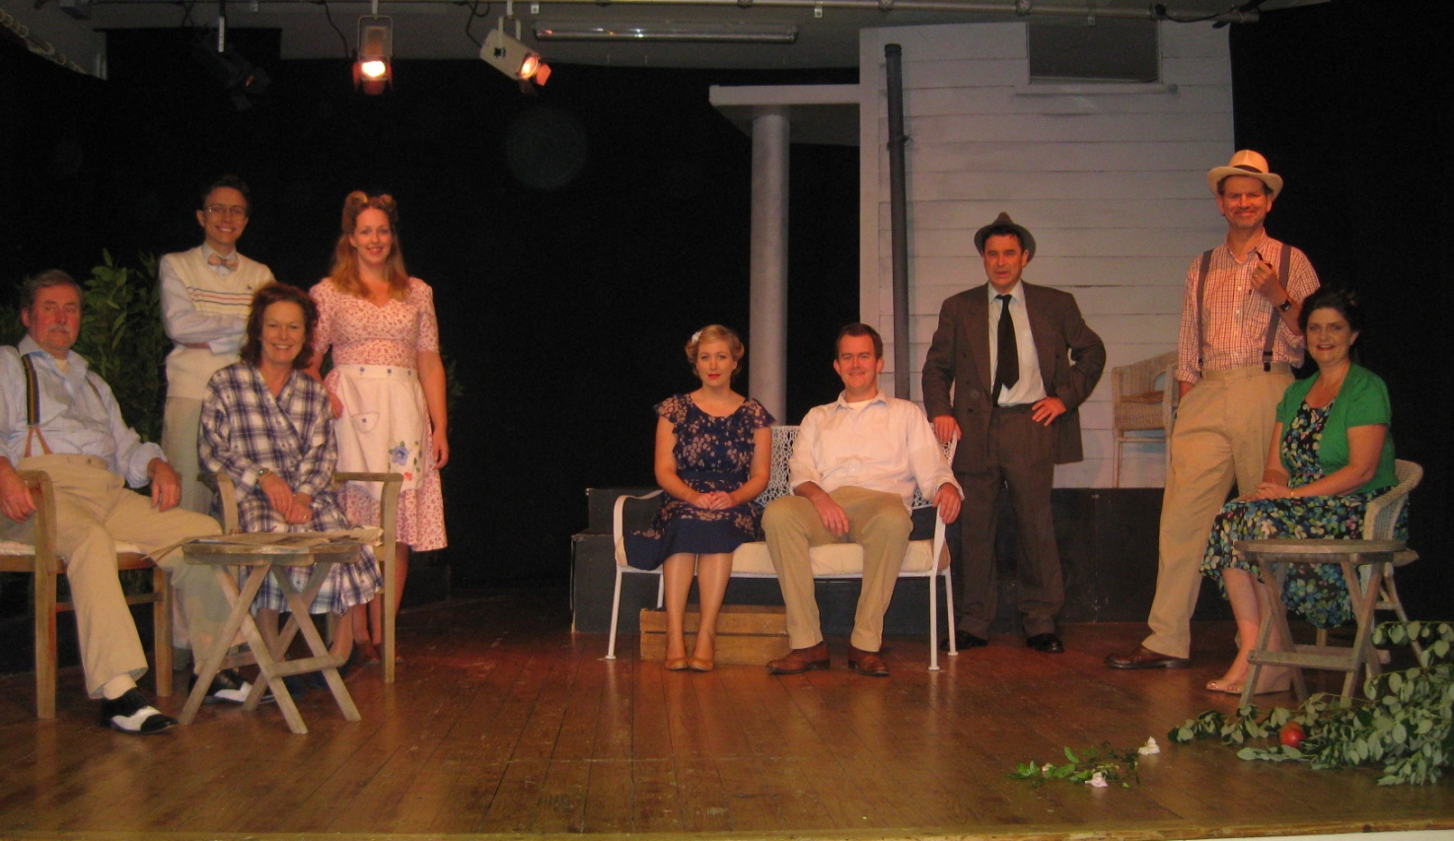
Our Autumn Production was a fantastic success and these are some of the messages we got afterwards.
Ann English Just to let you have my sincere congratulations to you and your cast on last week’s production of ‘All My Sons” It really was a great production, very powerful, very emotional and great acting by all on stage. There was not one ‘weak link’. As a matter of fact, for me it was the best play we’ve seen performed by DP for a few years. So take a bow and I look forward to your next direction.
Tara McGuire I recently went to see your production of All My Sons, which was a fantastic show all round. Ed Mulligan Excellent play and excellent performances by all, very good night. Florence Flynn Congrats on a great show…….. wonderful performances
All agreed that Aileen’ debut as director of a 3 Act play was a resounding success and she joins the list of illustrious Dalkey Players directors and we look forward to seeing her in action again. Aileen acknowledged Emma Jane’s assistance for the Sex and Violence elements in the story as she had more experience in that area !!!!!!!!! Fifty shades of Dalkey Players.
***********************************************************************************************
No sooner had the final curtain come down on AMS when we heard that we did not get the rights for our proposed Bray Festival Play due to its length.. Emer’s blood pressure elevated rapidly so a rapid rethink ensued and “ Two “ by Jim Cartwright was chosen so we wait with more baited breath to see if this will pass muster. In the meantime auditions for “ Two “ went ahead and Alan Nuzum and newcomer Tara Maguire were cast.
Dates for the Spring Production “Love Loss and what I Wore “were finalised. It will be done in the Kingston Hotel Dun Laoghaire the week of the 4th March 2013. Auditions were held before Christmas and the cast announced at the end of the month,
Cast for “Love Loss and what I Wore”
Emer Casey plays Gingy.
The other roles will be divided between
Emma Jane Nulty…. Sharon Nealon….Mary Carroll… Emma Mulligan ….. Maria Bruce.
Production manager Colm Kearns ……Stage Manager Aileen Byrne….. Props Geraldine McGrath
***************************************************************************************January 2013
We started with a read through of” Love Loss and what I Wore” in Lua’s house on Jan 3d. Emer had just moved house and could find nothing in the new abode. She was having a night off from “Two” due to Alan’s participation in the St Paul’s Pantomime Cinderella.
Clowning at the reading
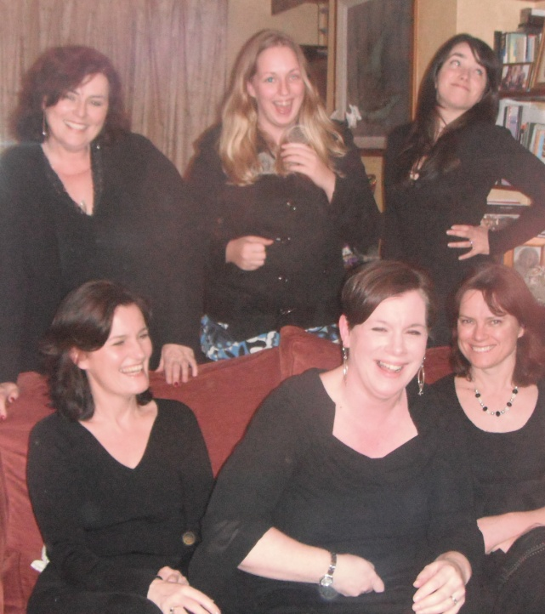
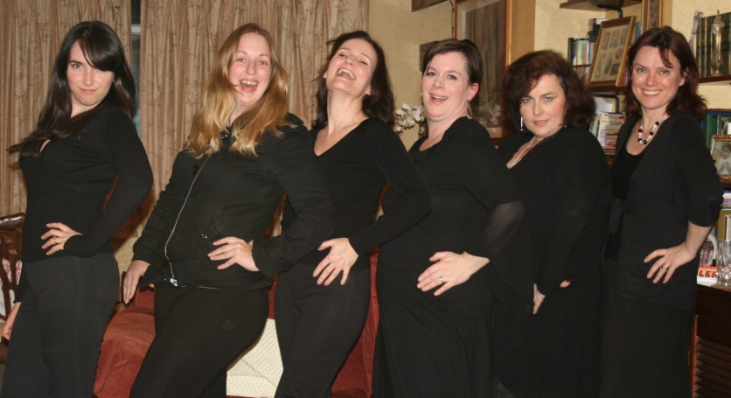
Above. From left
Maria Bruce, Emma Mulligan, Sharon Nealon, Emma Jane Nulty, Emer Casey, Mary Carroll .

Kris Kringle at the Belated Christmas Party Xmas Party.
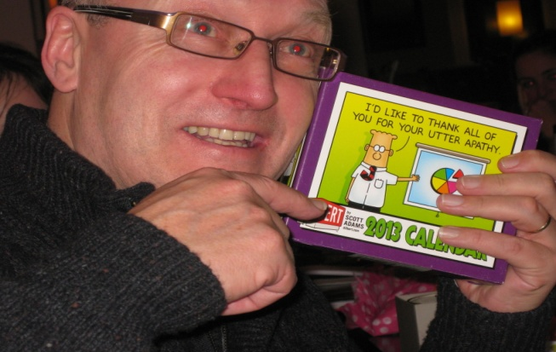
Were we trying to tell Paul something ?????
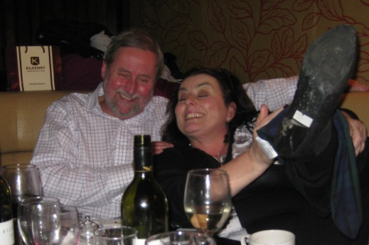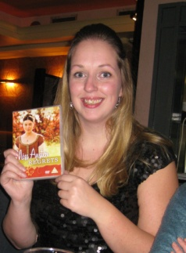 Emma’s DVD
Showing off Emer’s ankle warming device….. Badly needed.
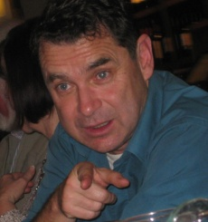 “I told you I’d get to act with Gabriel Byrne and YOU WOULDN’T BELIEVE ME!!!!!!!
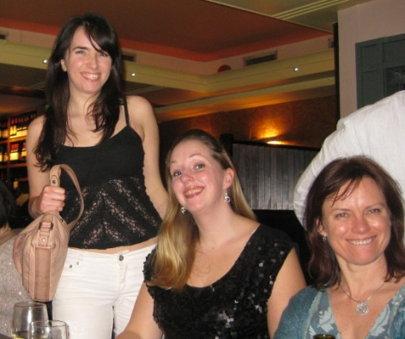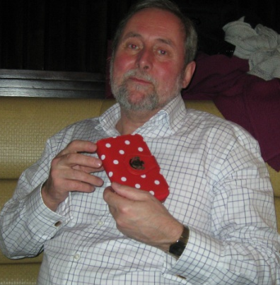
Maria Emma And Mary Phillip gets a “Purse” Paddy and Mary Rigney open up…….
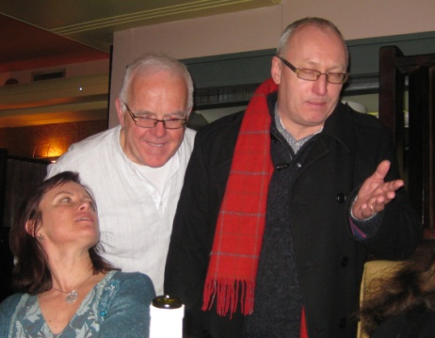
Lorcan fuels the conversation
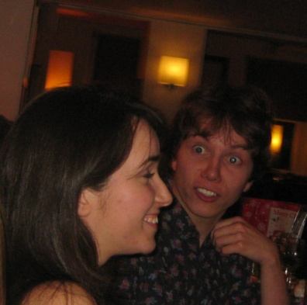
Incredulous Colm
Cristina

