2014- 2015
Chronicle

Gerry Clabby Chairman
Aileen Byrne Secretary
Donal Ryan Treasurer
Emma Jane Nulty Technical Skills Officer
Claudia Stokes O Dwyer P.R.O
David Butler Property Officer
Emma Mulligan Facebook updates
Rupert Heather Member
Alan Nuzum Member
Mary Carroll Member

Artistic Committee Emma Jane Nulty, (Chair) Lua McIlraith Aileen Byrne
Mo Hudson Rupert Heather

SEPTEMBER 2013

We started the year in Carry Hall Killiney our rehearsal venue, with the intention of doing ” Philadelphia Here I Come” directed by Aileen Byrne. We hoped that the large male cast would attract young men in their droves but sadly that did not happen so we resorted to Plan B. This was “Year of the Hiker” by John B Keane which was very quickly cast as follows
Sharon Nealon Geraldine McGrath Emma Mulligan
Alan Nuzum Colm Kearns, Rupert Heather
and new member Brian O’Sullivan
and ”Ole Ole Ole Ole” rehearsals got under way.
was the One Act chosen to go out on the All Ireland One Act Circuit directed by Emma Jane Nulty starring the amazing duo Mary Carroll and Claudia Stokes O Dwyer playing multiple parts . Talk about a roller coaster ride as the circuit circus hit 5 festivals in 7 days. We didn’t make it to the finals this time but had we the best fun running the “Original Irish Speed Dating Company” in so many venues? We received many acting and directing nominations along the way culminating in Claudia winning Best Actress in Mullagh Co Cavan.
We welcomed Siobhan Caskie, another newcomerto DP who was rapidly introduced to the art of stage management in tandem with Lua McIlraith while Emma Jane did Sound and another new face Phillip Goode handled Lighting. Sound design by Tom McMahon and costume as always by Mary Rigney.
Alongside the Autumn Production Lua McIlraith ran a series of 6 workshops. Using the DP Production Manual as a baseline, she explained the complexities of each role within the Production process and what was involved. New Members found this very helpful giving them a focus and understanding of what it takes to get a play from Page to Stage. Mary Rigney and Cyrileen Power also helped out in these workshops.
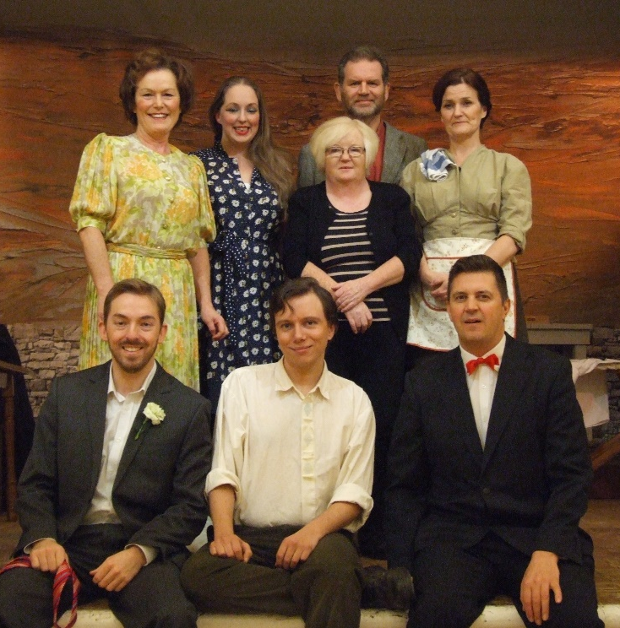
Yet another great Poster by our graphic genius Phillip Murphy
********************************************
The play was staged in the Dalkey Town Hall in November and received a great response and played to an audience who very much enjoyed the interpretation. Feedback from those who attended was extremely positive and the cast and crew certainly had a ball. 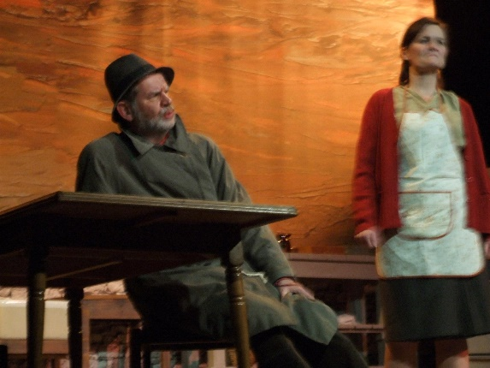 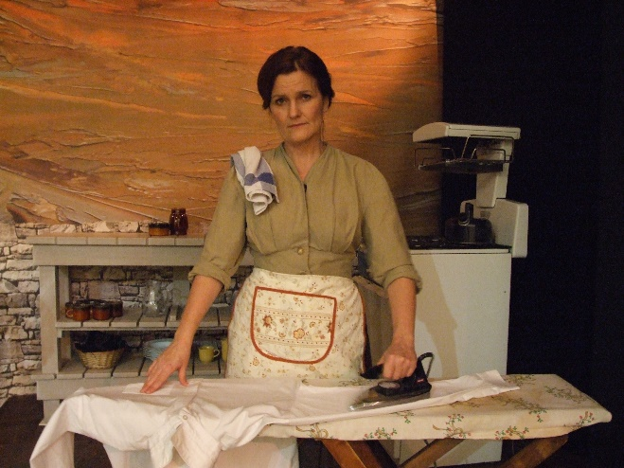 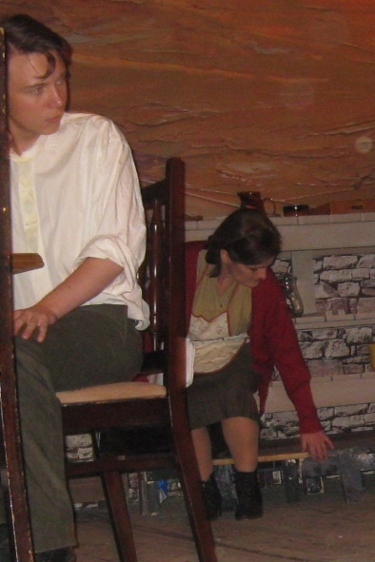 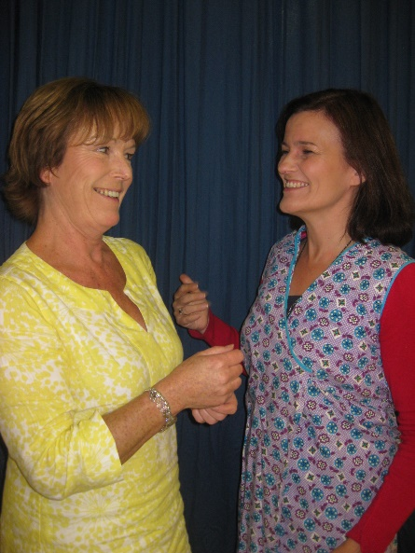
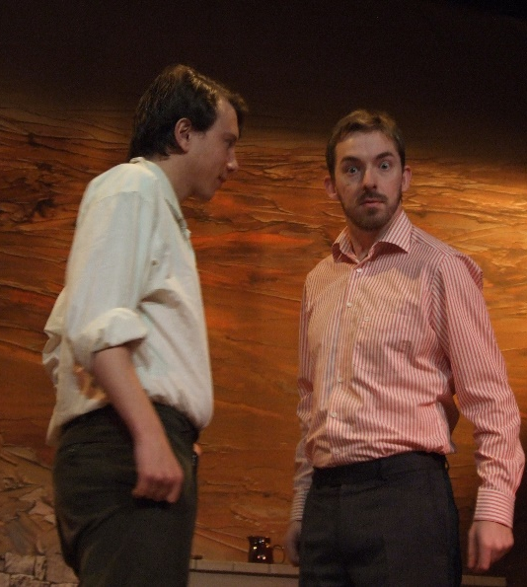
*************************************************************************************
This was definitely the Year of Plan B. Rupert Heather had hoped to direct the One Act for the January Bray Festival but work demands intervened and he had to withdraw. . Instead Lua McIlraith offered a play she had written for 5 women as an alternative and Aileen Byrne agreed to direct it fresh from the success of Hiker.
Cast Anna Rooney (great to have her back) Joanna Troughton Mo Hudson Cyrileen Power and Lua McIlraith
It was performed in the Kingston Hotel Dun Laoghaire prior to going to Bray. It was a real moment for DP, producing original work for this long standing Festival and Lua received the Adjudicators Award for her writing and Joanna was nominated for Best Supporting Actress.
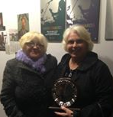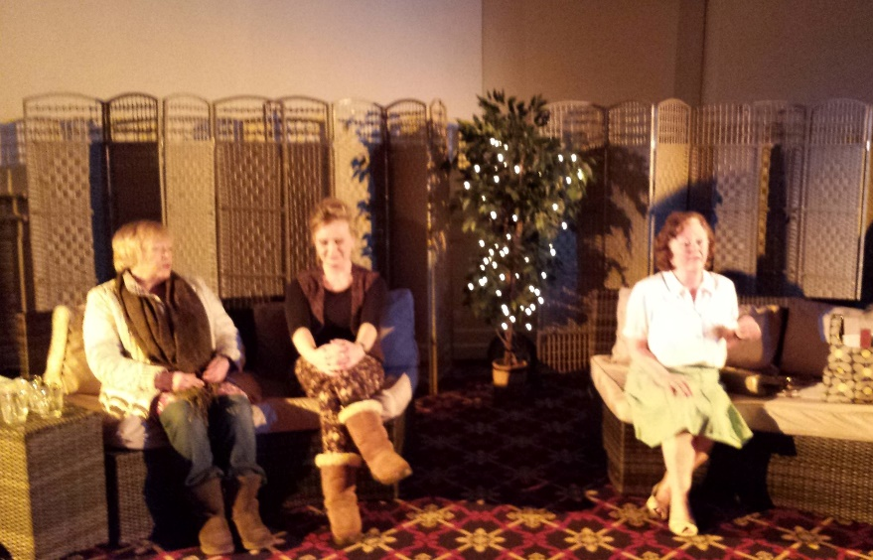
Aileen and Lua with Trophy Anna Mo And Cyrileen
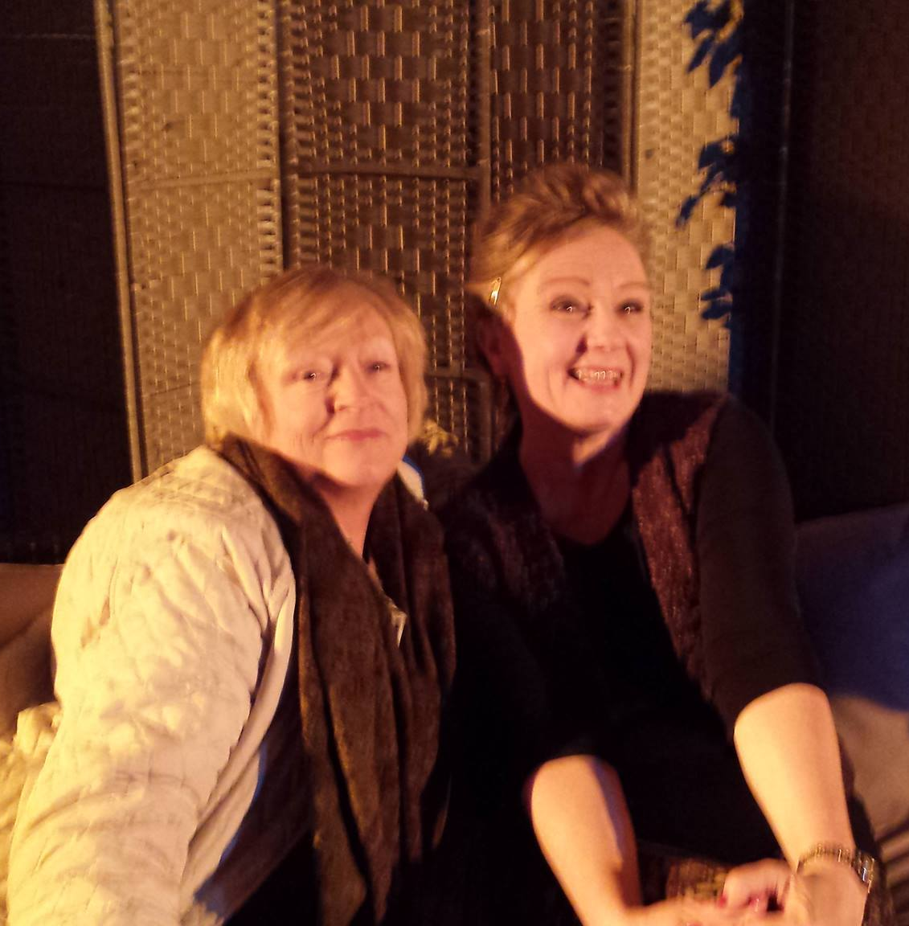 Anna and Mo Lua
The Year of Plan B continued into the Spring. Emma Jane had hoped to involve a number of directors in a production with multiple monologues but we just did not have enough interest in this type of quite innovative production. Plan B provided something just as quirky. “Dead Man’s Cell Phone” was a zany play which enabled the cast and crew to have great fun in finding ways to create multiple location scenes requiring instant set changes, props rearranged in rapid fashion to create these multiple scenarios so the Backstage crew were on stage quite a bit including taking part in a Cell Phone Ballet( don’t ask) .
Phillip designs once more with feeling.
Cast Dermot Byrne (back with us after along break) Maura Lavelle Mo Hudson Lua McIlraith Alan Nuzum Claudia Stokes O Dwyer
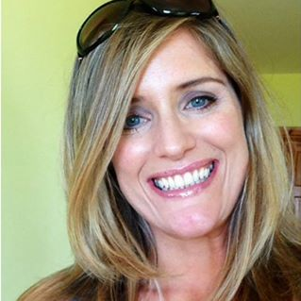
Hardworking Stage crew/ Crowd Scenes Emma Mulligan Colm Kearns and yet another new member Siobhan Galvin. Siobhan was a very fast learner being chucked in at the deep end of backstage madness. Emma was a great tutor and Colm was a treasure.
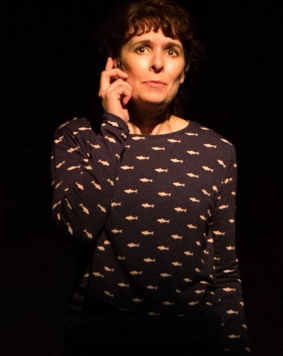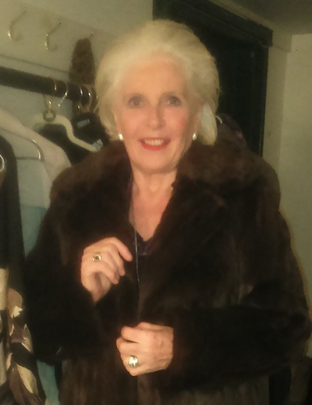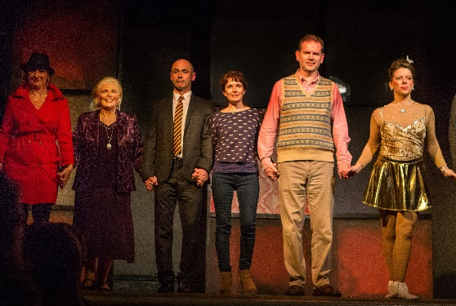
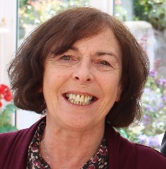
Milestones during the Year
Shelly Murphy was yet another new member to join this year having done Stage Manager for Bank of Ireland Drama Group many years earlier. Alongside the experienced Aideen Higgins they provided great back stage support for “The Year of the Hiker” and Shelly again turned out with Emma Mulligan and Claudia to provide the same service for Bray.
Kieron Dalton debuted as Production Manager for Aileen during ”Hiker” Thrown in at the deep end he swam brilliantly having digested the Production Manual in order to do the job. He also became a granddad and is relishing that role. Well done to both of you.

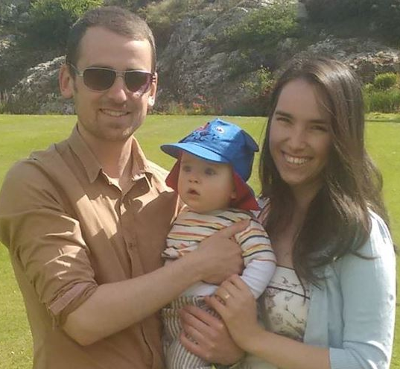
Maria Bruce had a beautiful baby boy in November. Patrick is getting big. Parents are still besotted……no time for Drama other than their own family drama.
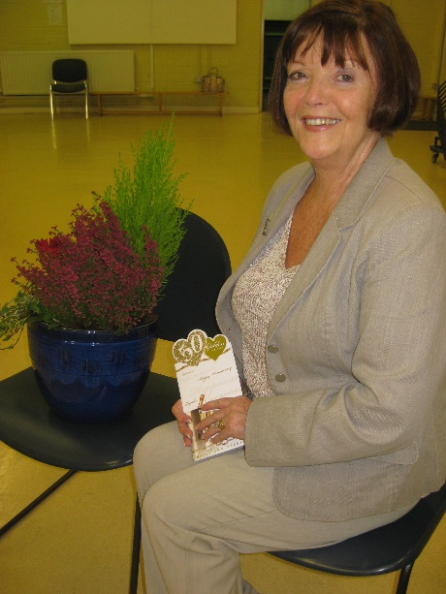
Mary and Paddy Rigney celebrated their Golden Wedding anniversary in fine style and DP presented Mary with a little memento for the occasion. DP also nominated Mary for her years of volunteering doing the costumes for the Group for which she won an award at a DLR Ceremony in April.
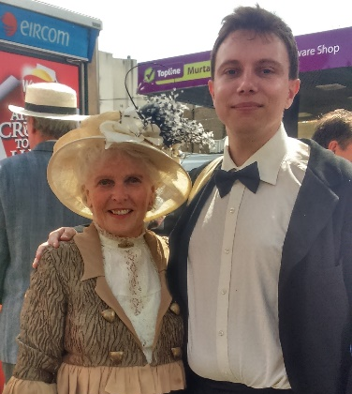
Bloomsday 2015
Colm Kearns has started to do his PHD so we wish him well with his studies. He was seen recently in Glasthule on Bloomsday in the company of another member who is well known !!!!!!
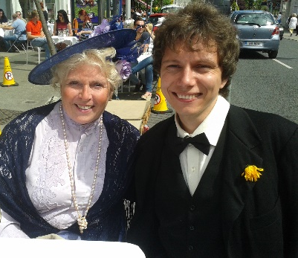
Bloomsday 2014
“We’ll have to stop meeting like this” !!!!!
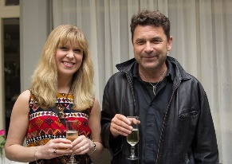
David Butler has had an exciting year artistically with the publishing of his latest book “City of Dis” which was nominated for an award at the Listowel Writers Festival. His play for Bray was also nominated for the Adjudicators award and to top off a great year he got engaged to the lovely Tanya .We wish them both every happiness and a long and happy life to gether.

In Memoriam
Our dearly loved Founder member Josie Dixon recently lost a second daughter to cancer . We again sympathise with her on the very sad loss of Diane comig so soon after Ken and Catherine . Many of the group attended the moving funeral service in St Paul’s Church.
David Butler said a sad farewell to his sister earlier in the season as did Paul Dignam to his mother and again the group was represented at their funerals.
“May flights of angels sing thee to thy rest “
_______________________________________________________________________________________
To finish our year with a major flourish DP received an invitation to Arus an Uachterain for a Drama groups Garden Party. Founder member Josie Dixon and Claudia Stokes O Dwyer were chosen( via names of paid up members out of the hat) while Lua attended in her capacity of Director of Dun Laoghaire Lilliput Players.

See you all in September

