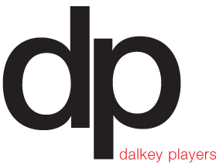
2015- 2016
Chronicle
Our 40th Season
Lua McIlraith Chairman
Siobhan Galvin Secretary
Donal Ryan Treasurer
Emma Mulligan Technical Skills Officer
Mary Carroll I.T Management
Emma Jane Nulty Member
Gerry Clabby Member
Alan Nuzum Member
Aileen Byrne Member

Artistic Committee Emma Jane Nulty, (Chair) Aileen Byrne Emma Mulligan Colm Kearns

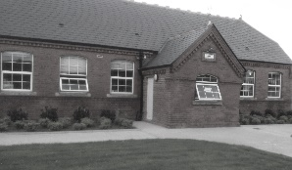

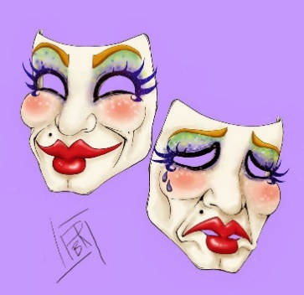 July/ August 2015
Our inaugural Event of the 40th Season was a visit to Áras an Uachtaráin for a Garden Party hosted by the President Michael D Higgins and his (former actress) wife Sabrina for representatives of Drama Groups around the country. Claudia and Lua attended on behalf of Dalkey Players and it was a fabulous day. Weather was perfect, the Arus and Gardens were wonderful, Michael D’s speech was both hilarious and appropriate and a great day was had by all.
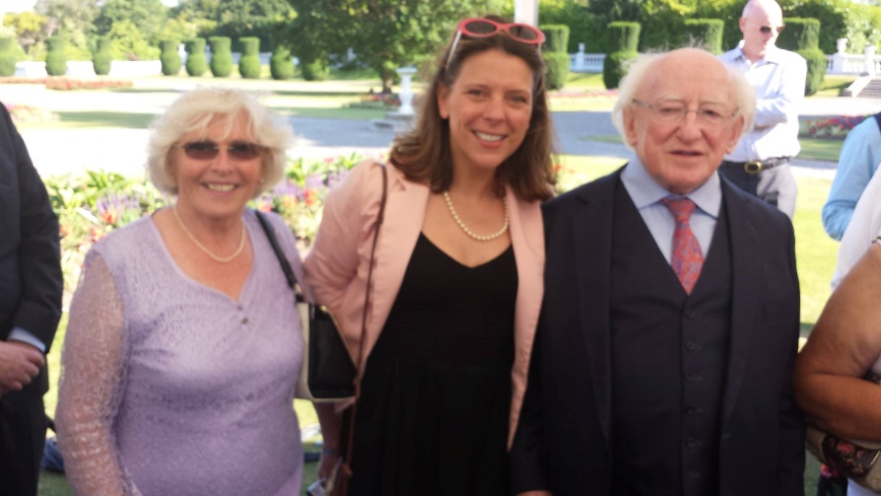
Then we started the current 2025/16 season with the brief from our AGM ringing in our ears. As this is our 40th Season and we have spent a number of years rehearsing in Killiney the majority of members felt it was time to source a rehearsal venue back in Dalkey.
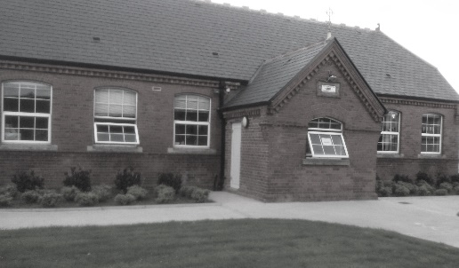
To cut a very long story short we finally achieved our goal and brokered a very advantageous deal with the Harold Boys School Board of Management and have spent a wonderfully comfortable year back in the heart of Dalkey. The room is perfect, we have extra rehearsal space available and the kitchen became the focus for socialising with numerous birthday cakes and good craic.
Next on the list was a “New Members” drive. Thanks to Mary Carroll’s bright idea we joined the online MeetUp group listings and advertised three Coffee mornings in the Tramyard Café for interested folks to come along and meet members and find out more about the DP. Eighteen prospective member attended with a variety of interests and were delighted with the opportunity to learn more about us.
The final item was to consider going back on the All Ireland Drama Circuit because long standing members had such wonderful memories of dashing round the countryside with our cast crew and sets, endeavouring to get to the Finals in Athlone (which we did on many previous occasions). It would require major fundraising but the enthusiastic Committee decided to go for it.
September -December.
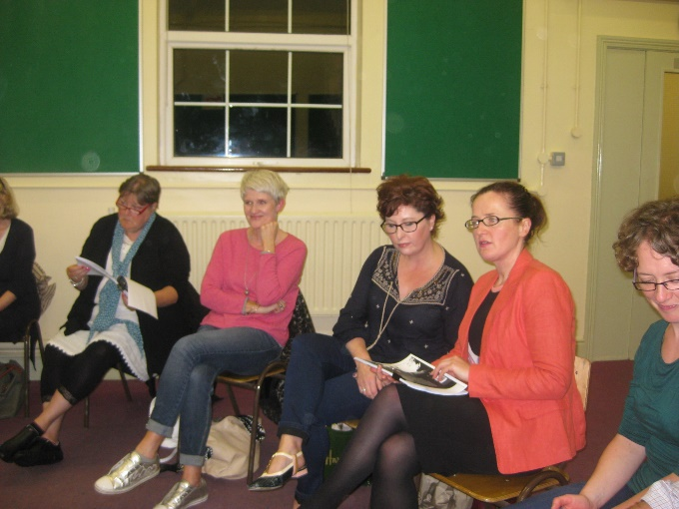
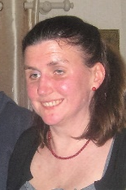
Opening night in Dalkey saw a huge turnout of current and prospective new members. Over thirty people attended to meet and hear the plans for the year which the Artistic Committee headed by Emma Jane Nulty had worked so hard over the summer months to prepare. From the 15 prospective members on the night five people joined up and over the next few weeks four more showed great interest and supported us during the year and will no doubt become members in September 2016.
New members this year Left Julia Crimmins and right Jean Larmour( 2 from left) Sarah Coughlan and Lorraine McRory 4th and 5th from left plus Alan Stewart. (See photo later)

The 2015-16 Programme.
Autumn Production “Molly Sweeney” by Brian Friel Directed by Aileen Byrne
One Act Festivals “Melody “ by Deirdre Kinehan Directed by Emma Mulligan (her debut as Director)
Spring Production “Jayne Eyre” For the Festival Circuit Directed by Emma Jane Nulty
Play Club Play readings and opportunity to try acting for new and inexperienced members.
Fundraising also swung into action with Tickets for the 400 Limited Draw being given to members to sell with the aim of making 2000 euro. Raffle to take place on the last night of the Autumn Production. Auditions went ahead for all three plays over the next few weeks and the following members took to the boards.
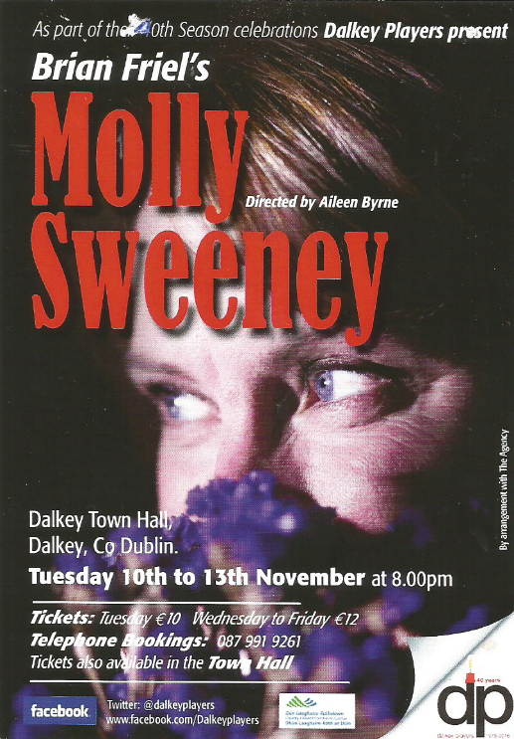
Mary Carroll played Molly Gerry Clabby played Frank her husband Alan Nuzum played Mr Rice an Ophthalmic surgeon. Rosemary Lynch Provided live singing each night
Aileen (in spite of being hospitalised during the Rehearsal period) did a fantastic directing job and riveting performance were given by the three actors to the delight of Dalkey audiences. Sadly Brian Friel died just a couple of weeks before our opening night so we were probably the first group to perform this play post mortem. A relative of the late author came to see the production and said it was one of the best “Molly Sweeney’s “she had ever seen, which was a compliment we will long treasure. Lua and Emma Jane provided major production back up for the show. New member Lorraine McRory did the sound for the show with a minimum of training needed.
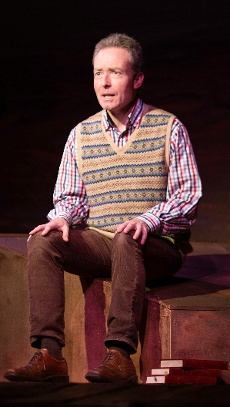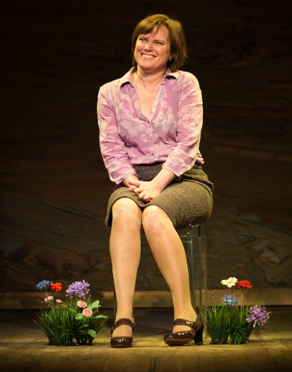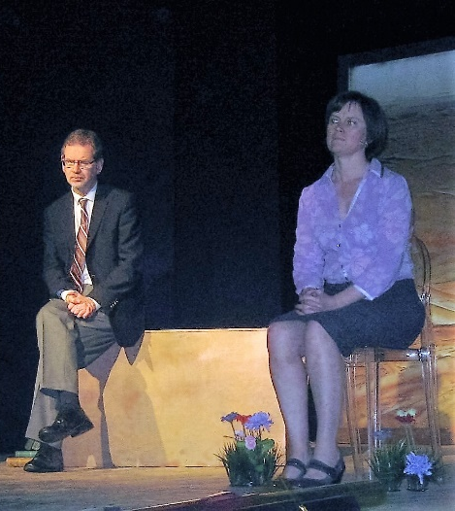
Gerry Mary Alan and Mary Rosemary

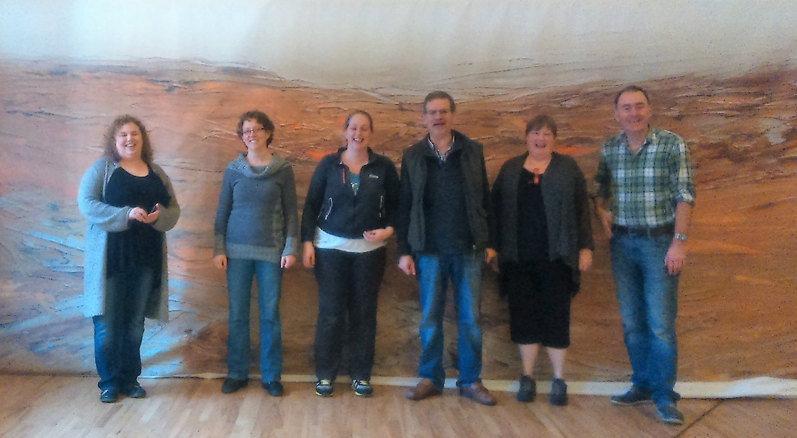
The Set Construction gang in front of the wonderful Backdrop originally created for the Hiker.
The Limited Raffle was won by a friend of Siobhan Galvin’s and it netted us a tidy profit. A great start to our 40th Season
Meanwhile Emma had cast her twosome for the One Act play” Melody” which was entered for Bray and Glenealy Festivals. Two newcomers to the Dalkey Stage were welcomed…Alan Stewart and our Secretary Siobhan Galvin. Aileen was on board as a mentor for Emma’s first outing as a director and rehearsals started. Emma Jane then cast “Jane Eyre which had been done in November 2013 but was deemed a really good circuit choice as it had a medium size cast and had not been on the circuit before. Only Maria Bruce and Maura Lavelle remained from the original cast and were joined by Dermot Byrne, Mo Hudson, David Butler, Lua McIlraith Alan Nuzum and newcomer Sarah Coughlan. Fun was being had by the Play Club who read many of the Small Plays for Ireland and took a crack at acting them out. We also read a play by interested newcomer Gavin Ryan “Oestogen Rising “ a black comedy with a nod to the !916 Celebrations to come. His partner Carolyn Coughlan also read with us until she broke her collar bone.
We learned early in the Autumn that our much loved hard working Life Member John Walsh was not well and undergoing treatment so we had him in our thoughts and prayers.
January 2016
The Year started with a bang as we partied in Lua’s house in Sandycove. The New Year event seems to have supplanted a Christmas party over the past few years and this timing does work far better. Something to look forward to when Xmas madness is dying down. However we still cling to the Kris Kindle Tradition and fun goodies were piled into the Xmas Basket. Great fun was had by all diving into the deep recesses of said basket. BYO was the order of the night and fuelled merriment, member interaction and a great sing song with Siobhan Caskie stunning us with her lovely voice. Hidden talent coming to the fore. Dermot was there with guitar and song ………roll on the next party.
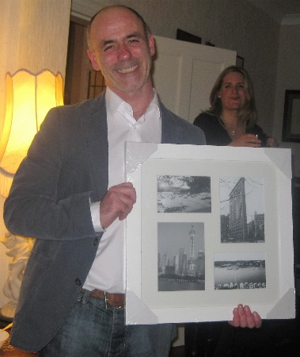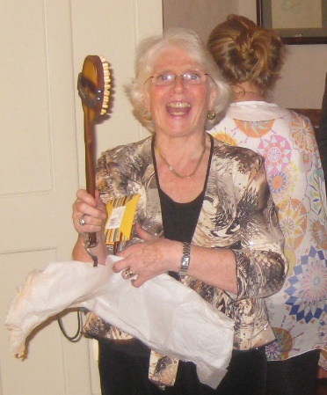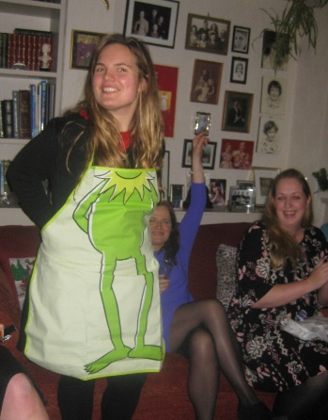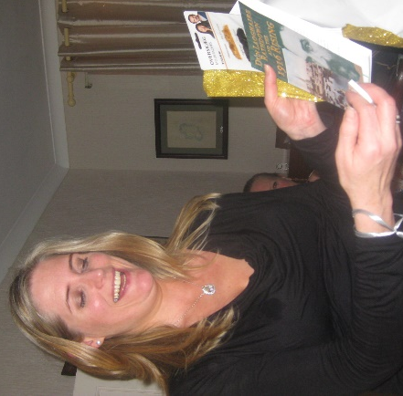
Some of the Kris Kindle Offerings.
**************************************************************************************
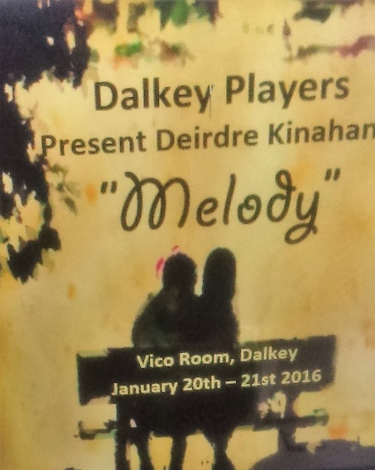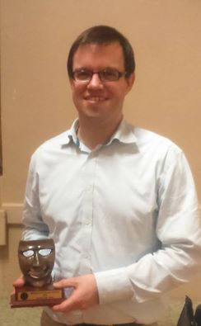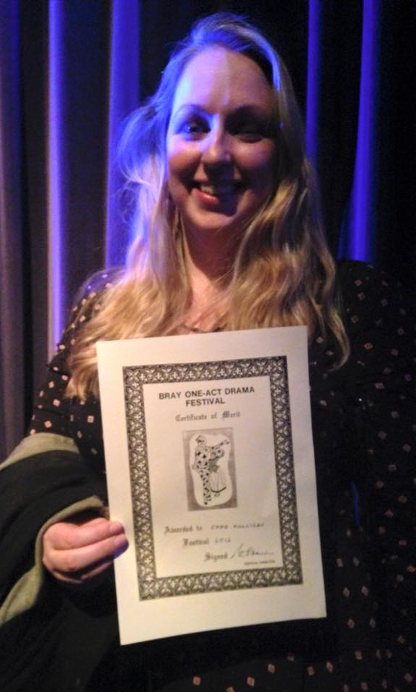
Alan and Siobhan Poster by Maria Bruce Alan Stewart Who else but…Emma
Then Bray and Glenealy Festivals beckoned with Emma in full flight as a first time director. Shelly Murphy and Julia did backstage with Shelly supplying mountains of food to be consumed onstage. Claudia and Jean Larmour also helped out. The results were very gratifying indeed. Alan Stewart got runner-up best Actor in both Venues, Siobhan Galvin got excellent Adjudications, while in Bray Emma Got a Merit Certificate for her first time directing and Tom and Kevin were nominated for Sound and Lighting. Another feather in DP’s Birthday cap.
The fundraising drive headed by Lua and Aileen was in full swing . The crafty idea of “Sponsor a Candle on our Birthday Cake” mooted by Alan was working and the money was slowly coming in. Dalkey Motor Company sponsored the back page of the programme for the Feb Production in the Town Hall and another big donation came from our sadly missed Caroline’s(RIP) Dad.

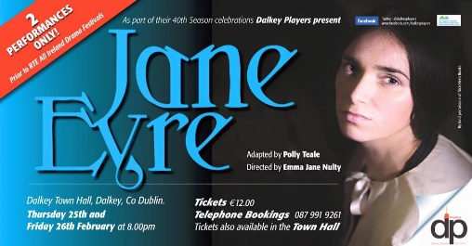
February.
Things were looking good on the rehearsal front for “Jane Eyre” We decided to do two nights in Dalkey as our preparation for the Circuit. We had secured 8 Festivals the length and width of the country which was going to be challenging to say the least. The Lighting Plot was the most intricate ever attempted by DP and was being designed by Barry Donaldson. It was not finalised for the dress rehearsal which was done practically in the dark and we had a marathon session in the Mill Theatre finishing at 1am to get it all on computer. I found a white feather on the stage as I left and thought……….does this mean what I think it might? More of that later. We played to excellent Houses with standing ovations and rave reviews both nights which really set us up for the 8 performances ahead. Sponsorship was coming in and we felt a bit more relaxed about the finances involved. This was the Marathon 8 days and a few nights of Janie’s travels around the Country,
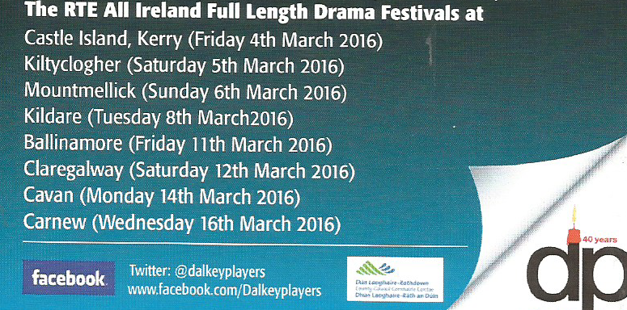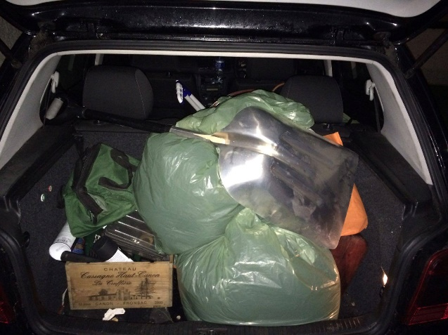
The Itinerary And never forget the Peat Moss
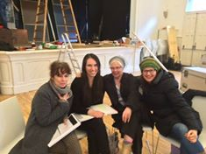
Doing the Circuit was an………….. “Hair raising, educational, cast and crew bonding , co-operational , “What’s App” writing, nail-biting, diesel/petrol glugging , tarpaulin flapping, Car overflowing , fun overnighting, sing songing, Barry guitar playing, Emma Jane hobbling, lights misfiring, sound disappearing, peat moss inhaling,, standing ovations, two second places 5 wins and 39 trophies…… EXPERIENCE.”
And that was without the brilliant photography from Dermo plus the Poetry to go with it not forgetting the magical Photos from the Kiltyclogher show by Liam Malaniff. I think that sums it up. We were so thrilled to get to Athlone and had a night in the School to show off our loot to the members
Left Set build and Line run Dalkey February 2016
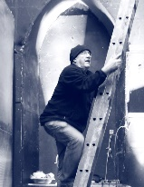 The Barry Pose (every venue)
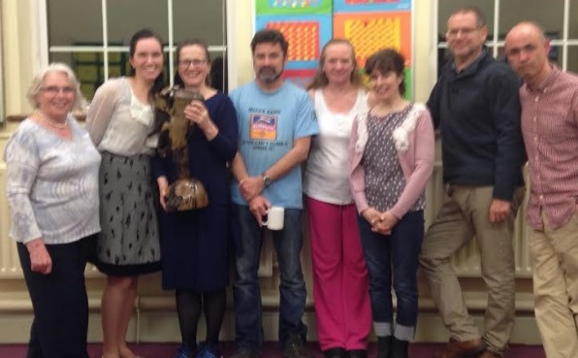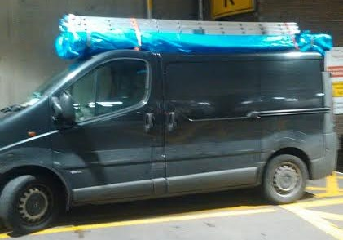
Ross Murphy joins the crew. The cast Barry’s van ready to roll 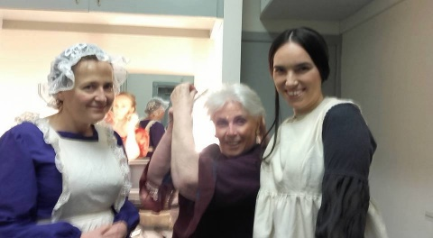 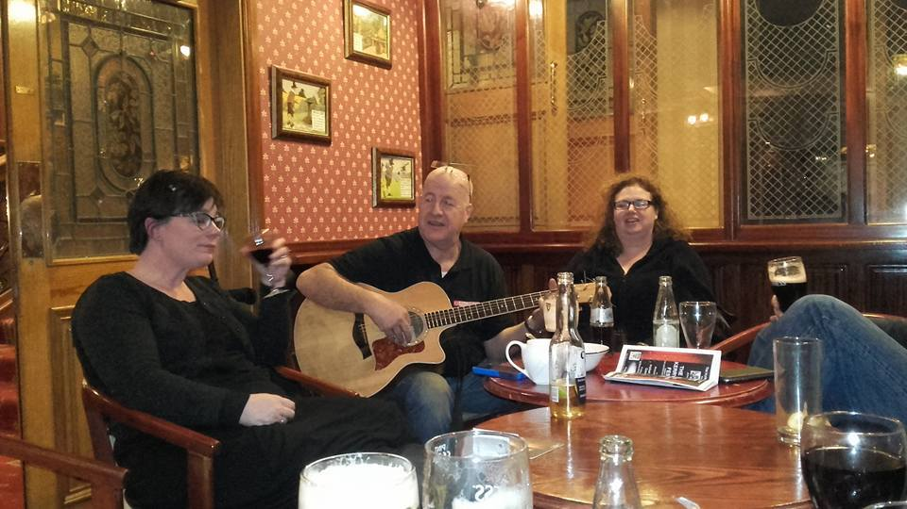
Dressing room Party time Costume repairs
In Action
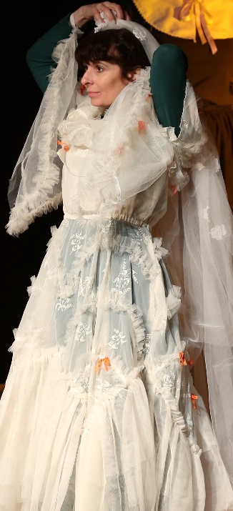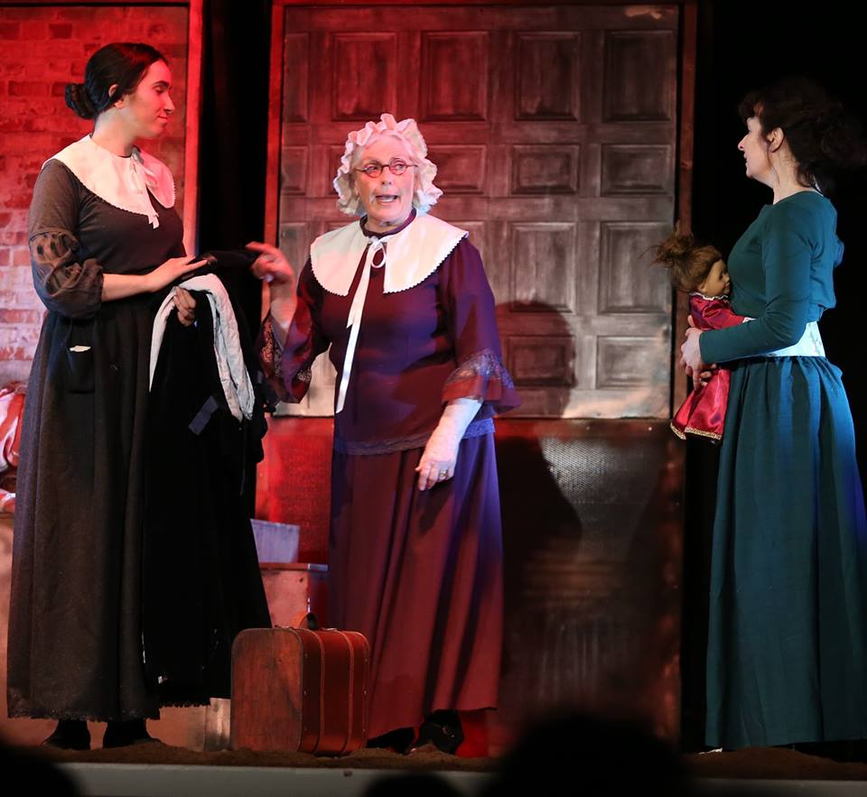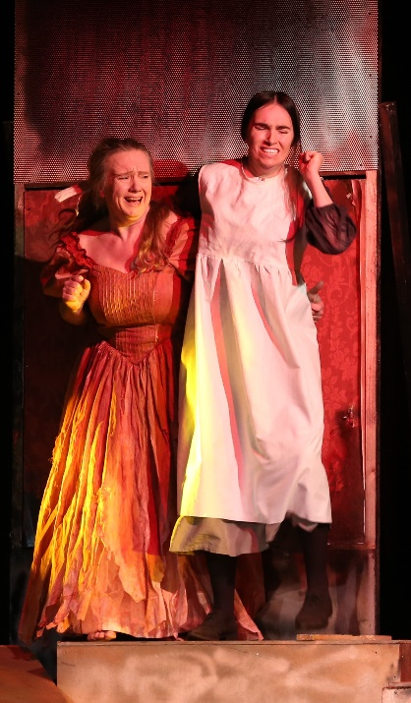

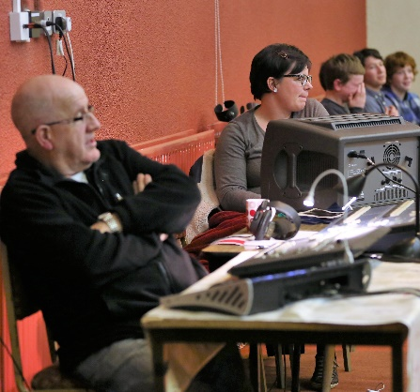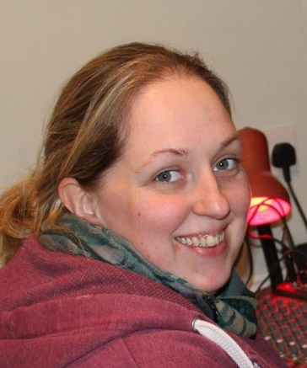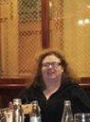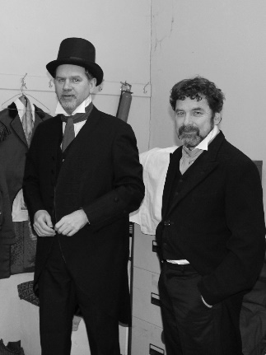
The worker bees……Barry and EJ Emma Shiv Alan and David

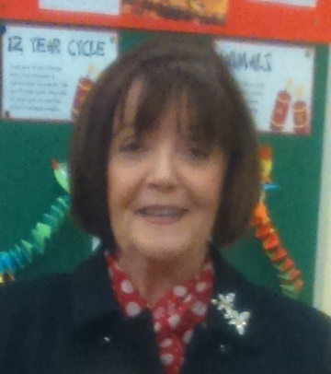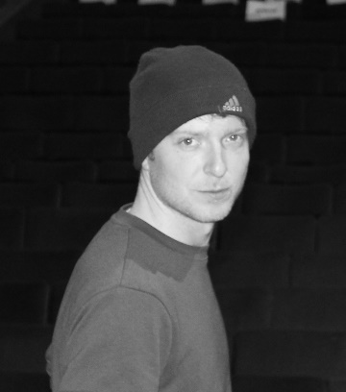
Mary R Ross Mary C
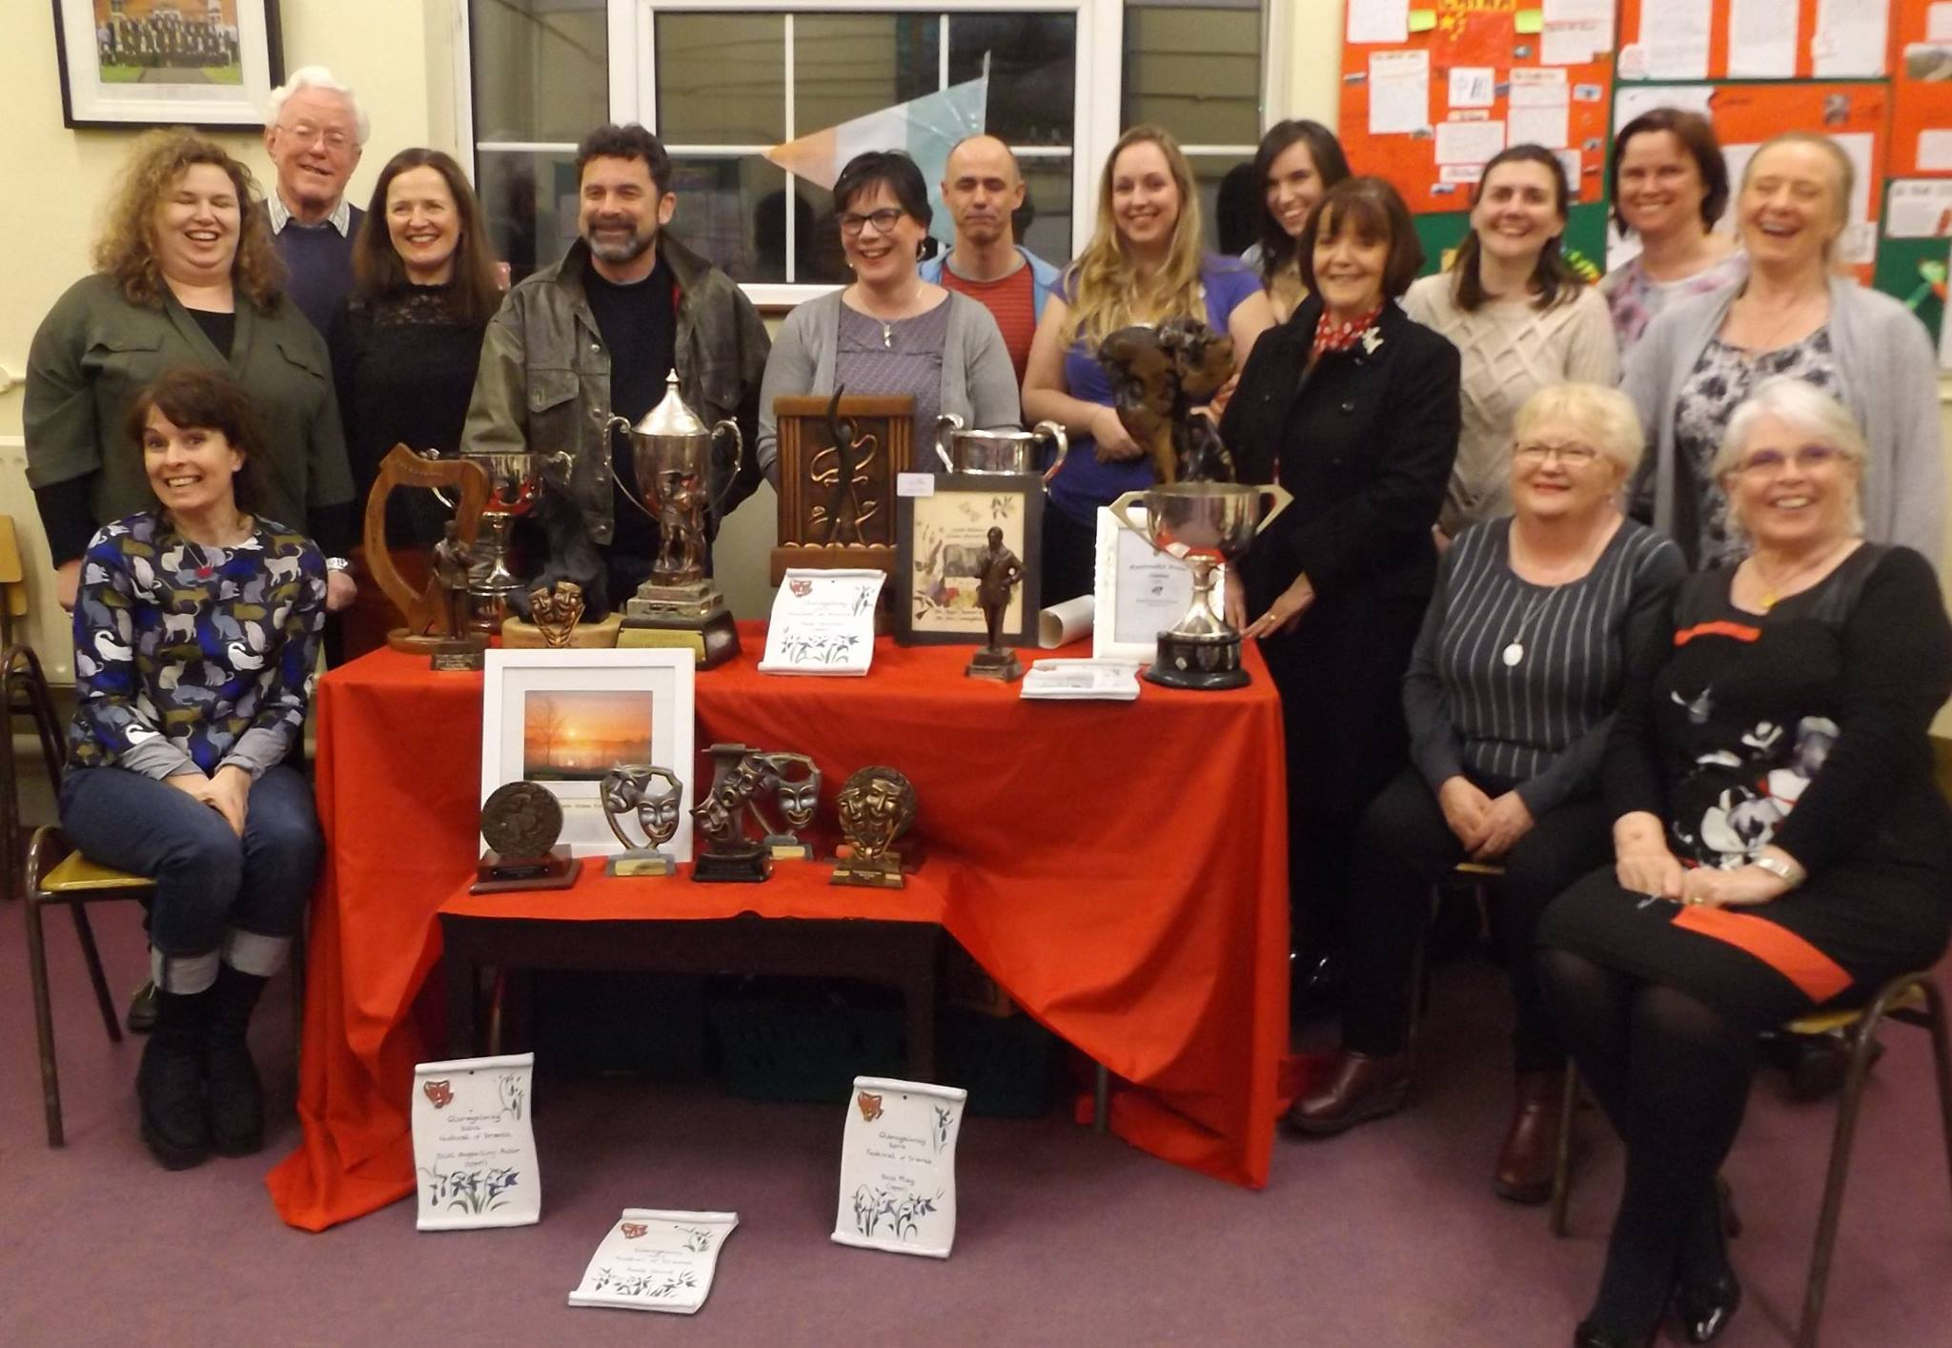
The Loot from 5 wins and two second places.
And so the “Jane Eyre Road Show” rolled on. Time to get back to Dalkey to prepare for Athlone.
We were over the moon about our exposure on the RTE Nationwide TV Programme . RTe came out to the Harold School to film us rehearsing, interview Emma Jane about her input, and a lovely section all to herself for Maria the Star of the Show…..it definitely improved our audience numbers.
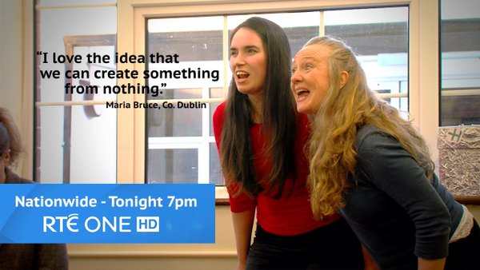
And we announced ourselves in style thanks to the Parish Church.
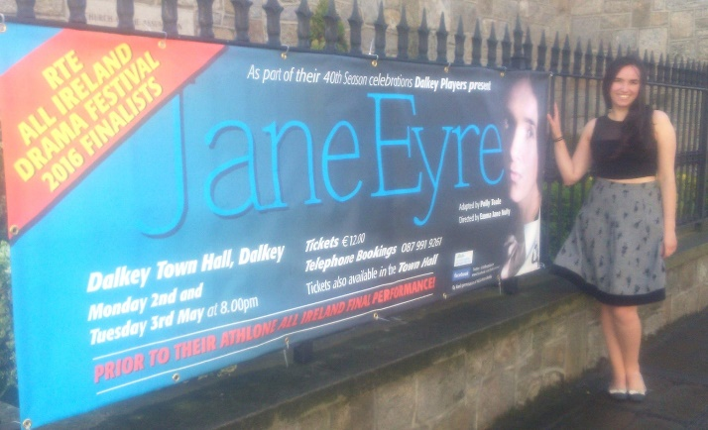
Maria meets her Alter Ego as we all get ready for another fabulous two nights in Dalkey with other Drama Groups who could not get tickets for the Athlone (sold out in ten minutes) Show coming to see it. We got two more standing ovations to add to the tally and the feedback was truly wonderful. 8 new Flats were being built for Athlone and this time we were wise and booked a big van which took everything we needed with The Blessed Barry at the wheel…..what a man!!!!!
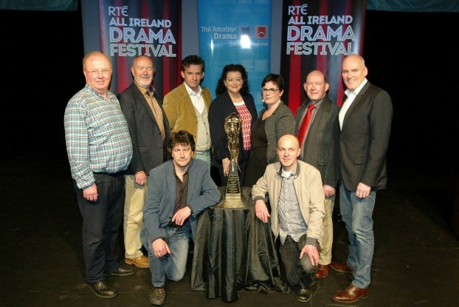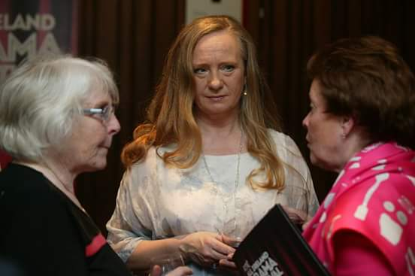
The Directors at the Draw for Dates EJ and Gerry happy with result Mo and Lua at the Abbey Launch
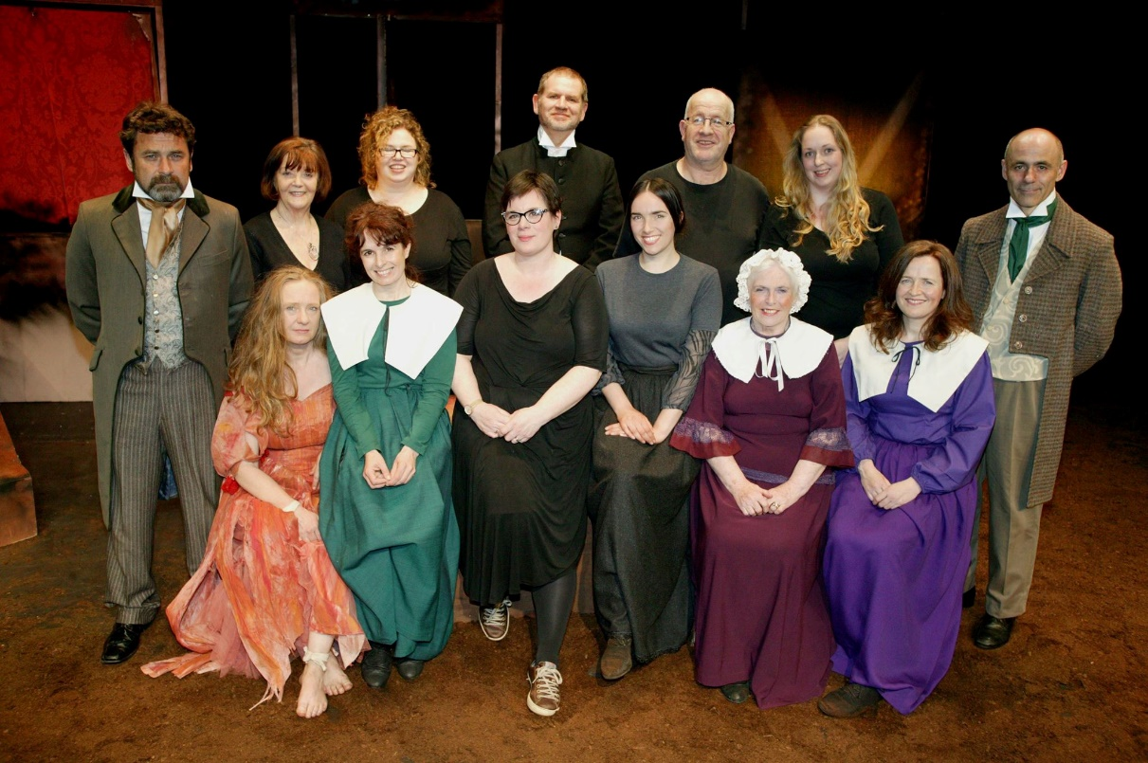
The Cast and Crew after the Athlone Performance
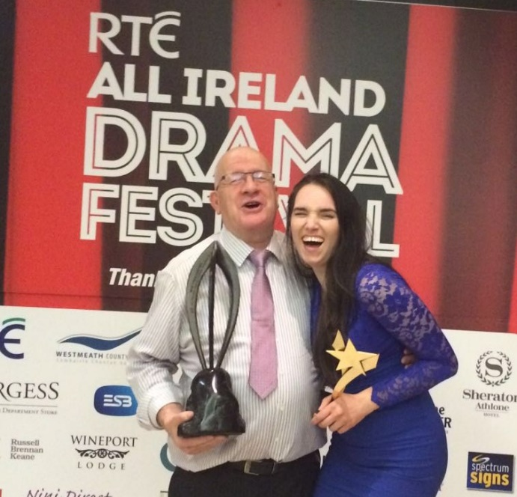
What can we say about performing in the Dean Crowe Theatre? Easily our most magical and best performance. We so enjoyed being out there and it was extra special for Lua whose parents were involved with the Theatre Festival from the very first one and for many years after. The audience loved it and it was the talk of the town for the next two days. The adjudication was very good and costumes came in for special mention alongside the acting and production elements. We went to the Bar after striking the set on a bit of a high. Entertainment was laid on but all had to do their party piece. Who would have guessed that Maura Lavelle had a hankering for Stand-up comedy….Maura great Joke telling …..Lua, Dermo Emma Jane Barry all sang and Lua got the trophy for best Act of the Night………..No 41. And then we had to wait until Saturday for the Gala Dinner and the big announcements.
WE WERE RUNNERS UP and in addition
Maria won Best Actress
Barry won Best Lighting.
We also got nominations for Best Director Emma Jane… Best Supporting Actor, Dermot, and Best Stage Management Emma and Siobhan. What a night!!We were ecstatic with relief and excitement. A year ago we did not dream this was possible but thanks to our Sponsors and a hard working Committee, Director, Cast and Crew…we (nearly) did it.
This brings our total of trophies won to 43!!!!!
Our sincere thanks to all the Members of Dalkey Players who supported us every inch of the way, coming down to rehearsals, coming to the various venues round the country, selling tickets, helping front of house…we could not have done it without you.
So many of the cast won awards on the Circuit that it is only fair that we highlight all of their many successes this year.
Results from the 8 Festivals | Awards | Recipients
Wins | 5
Second place | 2
Best Overall Play of Festival | 3
Best Director | 5 | Emma Jane Nulty
Best Visual Presentation | 1 | The Crew and set designers
Best Set | 2 | Emma Jane Nulty and David Butler
Best Lighting and Sound | 5 | Barry Donaldson, Tom McMahon and Emma Jane Nulty
Best Actress | 4 | Maria Bruce 3 Maura Lavelle 1
Best Actor | 3 | Dermot Byrne
Best Supporting Actress | 3 | Mo Hudson 2 Maura Lavelle 1
Best Supporting Actor | 4 | Alan Nuzum
Acting Certificate of Merit | 1 | Maura Lavelle
Best moments in Theatre | 2 | A )For the improvisation of a wheelchair from a bicycle wheel and b) The Horse aka Alan Nuzum
Athlone Results
Results | Runner up
Best Actress |  | Maria Bruce
Best Lighting |  | Barry Donaldson
Nominations | 3 | Emma Jane for Directing  Dermot for Best Supporting Actor  Emma and Shiv Caskie for Best Stage Management

The week after Athlone Dalkey was buzzing with the news of our success and the Community Council put us on the front page of their June Newsletter so we were delighted that all the Dalkey businesses who were so generous to us, got to hear of our win. Our Facebook page and email was alight with congratulatory messages and commiserations on coming so close to the Holy Grail. “There is always next year” was the mantra. BUT there was more to be done. The Birthday Gala Dinner had to be organised and we were delighted to be able to book this in the 1909 Restaurant. One of our sponsors) This was held on the 23d May and it was a lovely evening. A relaxed yet joyous atmosphere prevailed as we were still on an Athlone High. Founder member Josie Dixon was present as were long standing members John Walsh, Margaret Dunne, Ann English and Mary Rigney. Tales of DP in the good old days as well as more recent memories were shared………..We remembered those who were no longer with us especially Caroline and Hilary who left this world far too soon. 1909 tolerated us patiently until 1.30 am so a good night was had by all.
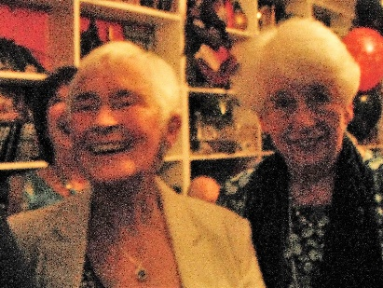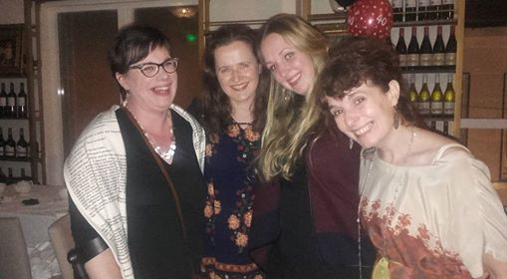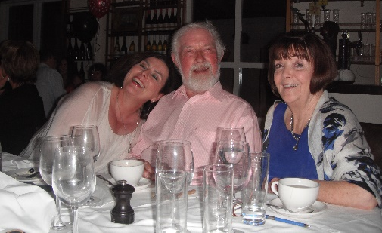
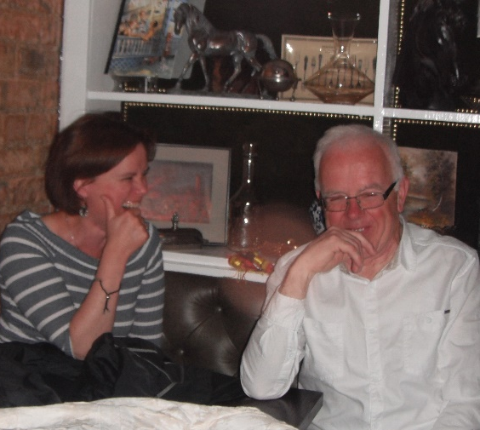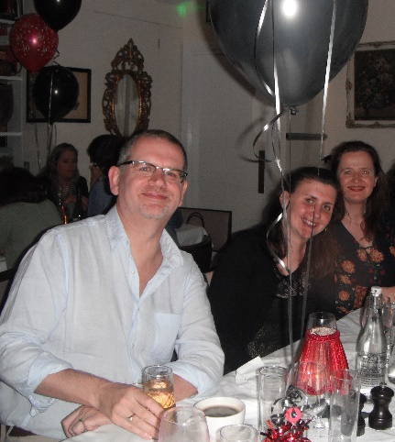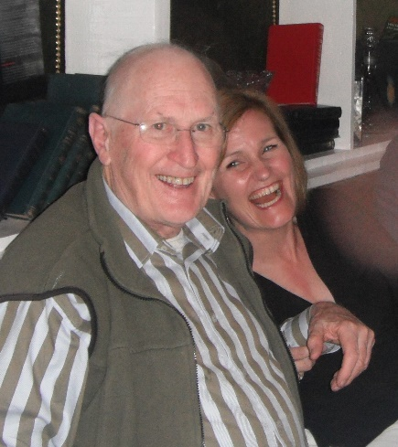
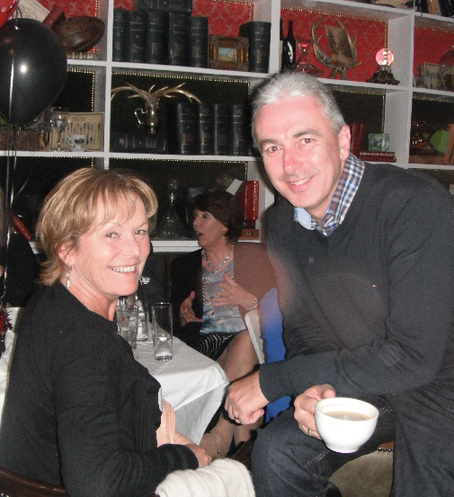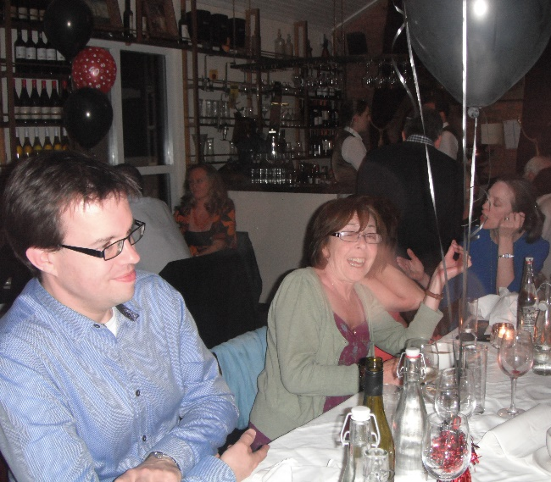
The Party People
***************************************************************************************Our final occasion of the 40th Year was the AGM held on June 9th in the Harold School. After all the reports of the year were delivered it was obvious that the Group are in really good shape artistically and financially and can look forward to another interesting year ahead. We are saying goodbye to Siobhan Galvin who is heading off to teach abroad later in the summer and she was thanked for all her input in the short time she was part of the Group. The Committee’s work is never ending and shortly we hope to tidy up our storage areas…. Aileen’s and Rosney Nulty’s garages to be precise. These two ladies provide us with this service free of charge and put up with our comings and goings uncomplainingly. We also have to buy clothes rails and hang the costumes stored in Cabinteely house Plus prepare the Autumn Programme…so no pressure then
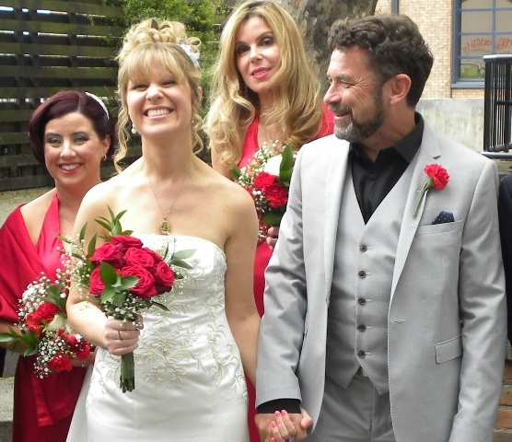
Milestones during the Year.
We have had so many theatrical milestones this year that it is nice to have something different to write about and that is the wedding of David Butler and Tanya his gorgeous bride. Luck was with him when the Athlone date did not coincide with his stag night And DP gave him quite a send off to that event with a searing Quiz (prepared by Tanya of course) and quizmaster Demo putting him through his paces. We hear
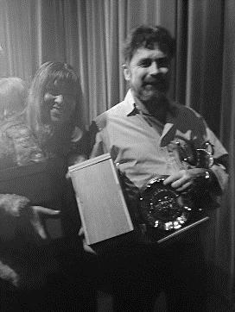
that the wedding” afters” was a blast and the honeymooners departed to Greece for a lazy trawl around the Islands.
On a theatrical note however David’s play “Blue Love “captured 5 prizes at the Bray Festival in January. Best Play…. Best director Best Lighting and Design Adjudicators Award for the Script and Best Actress so a huge Congrats on that success as well as all his other writing projects that are doing so well. Tanya also is a writer so this is definitely a marriage made in authorship heaven so may they have many years of double success ahead of them. Here they are with some of the Bray Trophies
***************************************************************************************
Remember the white feather I found in The Mill Theatre before the first Jane Eyre in February. Well friends of mine who believe in Angels told me that finding a feather in a place where you wouldn’t expect it to be, meant something good was going to happen…..boy were they right.

So everyone……have a wonderful, restful, exciting, enjoyable, sunny???? (Or whatever you’re having yourself) Summer

See you all on Thursday September 1st 2016
In the Harold Boys School
St Patricks Road
Dalkey.
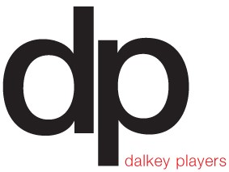

Lua McIlraith Editor June 2016

www.dalkeyplayers.ie dalkeyplayers@gmail.com
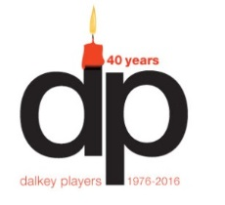
Sponsors of
Dalkey Players’ 40th Year

Mr Dermod Dwyer
Dalkey Motor Company
Core Credit Union Dalkey
Eugene O’Reilly Hyundai Ireland
Thyme Out Delicatessen
King’s Inn Dalkey
Rainbow Reflexology
Dalkey Pharmacy
Fitzpatrick’s Castle Hotel
Alan Nuzum Consulting.
Tom O’Higgins Estate Agent
Dalkey Auto Parts
Doyles Butchers
Killen Marine Dalkey
SuperValu Dalkey
McVerry Financial Services
O’Shea Manning Accountants
Fitzgerald’s Public House
Devilles Restaurant
Dandelion Hair Design
Joe O’Connor Optician
Benitos Restaurant
John Murphy Jeweller
1909 Restaurant
Cleggs Shoe Repairs
Zahra Media Group
Hicks Butchers

Eamonn Walshe Garage
The Queen’s Pub
Country Bake
Paul Gill Optician
Borza Takeaway
Growth Potential
Maxwell Pharmacy
Rhona’s Hair Salon
Celeste Hair and Beauty
Emma Jane Nulty
Bob Geldof
Lynn Geldof
Ann Kilty
Ann Hickey
Mr & Mrs J Chapman
Raffle prizes
Ragazzi Restaurant
Magpie Inn
Dalkey Newsagents
Paula Rowan Gloves
Grapevine Wines
Select Stores
Wine Buff
Marion Shine
Senso Studio Hair Salon
Bloomingdale Flowers
Kerins Pharmacy

